

REBOOT: NETWORKING



May 6, 2016

Boombastics

Institute of Technology, Blanchardstown



Declaration

We, the authors, declare that the material contained in this report, which is submitted for assessment on the programme of education for the award of B.Sc. Honours Degree in Computing in Information Technology in The Institute of Technology, Blanchardstown, Dublin 15, Republic of Ireland, on the twenty seventh day of April, in the year two thousand and sixteen, is entirely our own work, unless stated through official referencing and citation.

This document has not been submitted, in full or in part, for any other assessment, in this or any other institution, with the exception of those required by our mentors in order to achieve the above qualification. The only authorized breech of this statement is the submission of the testing chapter, in part, which is also being submitted as a standalone document for the purpose of assessing the added member as an independent assignment. This has been officially authorized by our mentors.

The information contained within these pages is, to the best of our knowledge, true and accurate at the time of publication, and is solely for informational purposes. Boombastics™ shall not be responsible for or liable in respect of errors or omissions from these pages.

Acknowledgment

To ensure the success of this assignment, we required a reasonable amount of guidance and support from several reputable individuals. Among those are ITB resident lecturers Ms. Aoife Fox and Mr. Mark Lane MSc, who tirelessly aided us in the technique of thesis development, and security protocols, respectively.

We would like to take this opportunity to convey our utmost gratitude to Dr. Luke Raeside, Department of Informatics faculty, Institute of Technology, Blanchardstown, who was a mentor, supervisor and friend throughout the project process. His endless advice and many consultations for the duration of the academic year was nothing short of excellence. He was approachable, forthcoming, and most importantly, honest with us as a team and as individual students.

A special thanks must be directed to a newly found friend and colleague. Alcidemar Lopes was a welcomed addition to the process, bringing with him an alternative approach to coding which comes from his Brazilian heritage. As a student on ITB’s Erasmus programme, Alcidemar joined the team at the half-way mark, but adjusted well, despite language and cultural differences. The bonds created in the duration of this project are concrete.

In recognition of his technical skills, we as a team are grateful to the assistance that our peer and colleague, Colin Forrester, gave selflessly when we required it. His vision for computer software resulted in a valuable resource to this project.

At this time we would like to acknowledge the patience and support that our families have given us in our pursuit of achievement. We thank all of those individuals who, directly and indirectly, have added to the harmony which surrounded us during this time.

“The will to persevere is often the difference between failure and success.”  
David Sarnoff

Abstract

The purpose of this project was to develop and interactive web-based mobile application for third level students who are studying in the area of networking. The software was developed with the theory that this application is adaptable for use with any academic module by altering the content of a database.

The design of this application is based on the concept of a multiple choice quiz with the emphasis on academic learning married with entertainment. While achieving the goal of providing an educational tool for students, this application focused on developing an inviting and easy-to-use game to help support students in the initial learning of networking terms and definitions.

On completion, this application offers a simple and ergonomic front-end design which is user friendly and aesthetically pleasing when held against trending applications. The back-end is flexible and can be adapted to most theoretical modules, with little expertise.

Since the programming is modular, this application can be expanded and altered to fit the needs of the clients’ specific requirements.

 Android QR Code Other Devices QR Code

Android QR Code



Other Devices QR Code

The Team

**Ryan Mackenzie CTO B00069707**

Ryan is a programming wizard (or so he thinks) who has an abundant supply of enthusiasm. He was a valuable member of the team once he learned to calm down a bit. His vision for the project was complimented by his willingness to negotiate on a daily basis. Boombastics love him.

** Alcidemar Lopes De Araujo Netto TTO B00084666**

This smokey little genius is only a temporary addition to the country. Originally from Brazil, Alcidemar was a late-comer to the project. After extensive interviews and police checks, we invited him to join Boombastics™ to enforce a stringent testing regime. Well, that was the plan. He contributed to the main program on several occasions but was able to refocus on his own department. Ireland and Boombastics love him!!

**Darren Cosgrave CGO B00067349**

Darren is a mysterious creature. Hard to pin down, but once captured, is a diligent and hard-working beast. He brought a lot to this project including the art of challenging the code, and button manipulation. With a keen eye for graphics (ehem!), Darren brought a lot to the GUI design and implementation whenever he was around. Boombastics love him.

 **Rachel Egan CPO B00075594**

Rachel brought a skill set similar to that of a famous German dictator, whose name escapes me at this time, overseeing project deadlines and being sure to help keep the team on track. Rachel's creative side came into play when designing the application in order for the best user experience. Rachel's constant blabbering of all the research she conducted aided greatly in not only the coding side of the project but the written also. Boombastics HATE her.

Table of Contents

[1 Introduction 1](#_Toc450049233)

[1.1 Aims and Objectives 2](#_Toc450049234)

[1.2 Target Audience 3](#_Toc450049235)

[1.3 Main Research Questions 4](#_Toc450049236)

[1.4 Justification/Benefits 5](#_Toc450049237)

[1.5 Feasibility 6](#_Toc450049238)

[1.6 Systems Development Life Cycle (SDLC) 7](#_Toc450049239)

[1.7 Proposed Methodologies 8](#_Toc450049240)

[1.7.1 Member 1 8](#_Toc450049241)

[1.7.2 Member 2 8](#_Toc450049242)

[1.7.3 Member 3 8](#_Toc450049243)

[1.7.4 Member 4 9](#_Toc450049244)

[1.7.5 Group Elements 9](#_Toc450049245)

[1.8 Application 10](#_Toc450049246)

[1.8.1 Level 1 10](#_Toc450049247)

[1.8.2 Level 2 10](#_Toc450049248)

[1.8.3 Level 3 10](#_Toc450049249)

[1.8.4 Player advancement through levels 10](#_Toc450049250)

[1.9 Deliverables 11](#_Toc450049251)

[1.9.1 Expected Results 11](#_Toc450049252)

[1.9.2 Work Breakdown Structure 12](#_Toc450049253)

[1.9.3 Gantt-Chart 12](#_Toc450049254)

[Planning Review 13](#_Toc450049255)

[2 Literature review 14](#_Toc450049256)

[2.1 Review A: Is a multiple choice quiz (MCQ) an efficient and effective format of assessing students? 15](#_Toc450049257)

[2.1.1 Where MCQ testing came from 16](#_Toc450049258)

[2.1.2 MCQ - an effective format for testing? 17](#_Toc450049259)

[2.1.3 Advantages and disadvantages of using MCQs as a method of testing 19](#_Toc450049260)

[2.1.4 Essay Exams verses Multiple Choice Quiz 20](#_Toc450049261)

[2.1.5 Conclusion 21](#_Toc450049262)

[2.2 Review B: How the implementation of Multiple Choice Quizzes (MCQs) on mobile devices for 3rd level students can aid in their subject of choice. 22](#_Toc450049263)

[2.2.1 MCQs – are they used? 22](#_Toc450049264)

[2.2.2 E-Learning and M-Learning 24](#_Toc450049265)

[2.2.3 Technology in study 25](#_Toc450049266)

[2.2.4 Web Services for Mobile Learning Applications 27](#_Toc450049267)

[2.2.5 Conclusion 28](#_Toc450049268)

[2.3 Review C: A synoptic review in to the technology to be used in the development of an educational application with the subject of Computer Networking 29](#_Toc450049269)

[2.3.1 Java 29](#_Toc450049270)

[2.3.2 PHP 30](#_Toc450049271)

[2.3.3 HTML 31](#_Toc450049272)

[2.3.4 CSS 32](#_Toc450049273)

[2.3.5 JavaScript 32](#_Toc450049274)

[2.3.6 Android 33](#_Toc450049275)

[2.3.7 Bootstrap Framework 34](#_Toc450049276)

[2.3.8 Conclusion 35](#_Toc450049277)

[3 Implementation 36](#_Toc450049278)

[3.1 Code Structure 36](#_Toc450049279)

[3.2 Data Schema Design 36](#_Toc450049280)

[4 Design 37](#_Toc450049281)

[4.1 User Interface Design (Wireframes) 37](#_Toc450049282)

[4.2 Colour 39](#_Toc450049283)

[4.2.1 Mauve 39](#_Toc450049284)

[4.2.2 Amethyst 39](#_Toc450049285)

[4.2.3 Logo 40](#_Toc450049286)

[4.3 Layout 41](#_Toc450049287)

[4.3.1 Animation 41](#_Toc450049288)

[4.3.2 General Layout 44](#_Toc450049289)

[4.4 Research into similar games 47](#_Toc450049290)

[4.4.1 “Networking Exam” 47](#_Toc450049291)

[4.4.2 “Cisco Packet Tracer Mobile” 48](#_Toc450049292)

[4.4.3 “Great Quiz (Trivia game)” 48](#_Toc450049293)

[4.5 Application Frameworks 49](#_Toc450049294)

[4.6 Back-End Design 50](#_Toc450049295)

[4.7 Proposed Versioning Control System 51](#_Toc450049296)

[5 Walkthrough 52](#_Toc450049297)

[5.1 Screenshots of program walkthrough 52](#_Toc450049298)

[5.2 UMLs 57](#_Toc450049299)

[5.2.1 Class Diagram 57](#_Toc450049300)

[5.2.2 Use Case diagrams 58](#_Toc450049301)

[6 Technology used and Additional features 61](#_Toc450049302)

[6.1 Hosting Technology 61](#_Toc450049303)

[6.2 Cookies 61](#_Toc450049304)

[6.3 Live Chat 62](#_Toc450049305)

[6.4 Email 63](#_Toc450049306)

[6.5 Technology Quick Reference 64](#_Toc450049307)

[7 Security 65](#_Toc450049308)

[7.1 OWASP 65](#_Toc450049309)

[7.2 OWASP Top 10 66](#_Toc450049310)

[7.2.1 Injection (SQL Injection) 66](#_Toc450049311)

[7.2.2 Broken Authentication and Session Management 66](#_Toc450049312)

[7.2.3 Cross Site Scripting (XSS) 67](#_Toc450049313)

[7.2.4 Insecure Direct Object Reference 67](#_Toc450049314)

[7.2.5 Security Misconfiguration 67](#_Toc450049315)

[7.2.6 Sensitive Data Exposure 68](#_Toc450049316)

[7.2.7 Missing Function Level Access Control 68](#_Toc450049317)

[7.2.8 Unvalidated Redirect and Forwards 68](#_Toc450049318)

[7.2.9 Cross Site Request Forgery (CSRF or XSRF) 69](#_Toc450049319)

[7.2.10 Using Components with Known Vulnerabilities 69](#_Toc450049320)

[7.2.11 DDoS Attack 70](#_Toc450049321)

[7.2.12 Man-in-the-middle-attack 70](#_Toc450049322)

[8 Testing 71](#_Toc450049323)

[8.1 The importance of testing 71](#_Toc450049324)

[8.2 Software Testing Phases 72](#_Toc450049325)

[8.2.1 Usability 72](#_Toc450049326)

[8.2.2 Functional 73](#_Toc450049327)

[8.2.3 Compatibility 74](#_Toc450049328)

[8.2.4 Database 74](#_Toc450049329)

[8.2.5 Installation 75](#_Toc450049330)

[8.3 Test Journal as of 24-04-2016 77](#_Toc450049331)

[8.3.1 Usability Tests 77](#_Toc450049332)

[8.3.2 Functional Tests 81](#_Toc450049333)

[8.3.3 Compatibility Tests 82](#_Toc450049334)

[8.3.4 Database Tests 84](#_Toc450049335)

[8.3.5 Installation Tests 86](#_Toc450049336)

[8.4 Notes 86](#_Toc450049337)

[9 Findings 87](#_Toc450049338)

[9.1 Score Function 87](#_Toc450049339)

[9.2 Level 3 87](#_Toc450049340)

[9.3 Sounds 87](#_Toc450049341)

[Conclusion 88](#_Toc450049342)

[Appendix 89](#_Toc450049343)

[References 91](#_Toc450049344)

[Bibliography 95](#_Toc450049345)

Table of figures

[Figure 1‑1 - The Prototyping Model 7](file:///C:\Users\Rachel\Desktop\FINAL%20THESIS.docx#_Toc450049346)

[Figure 1‑2 - Gantt-Chart 12](#_Toc450049347)

[Figure 2‑1 - An example of a Multiple Choice Quiz 15](#_Toc450049348)

[Figure 2‑2 - A graph to show the steady rise in the usage of PhP since January 2000 30](#_Toc450049349)

[Figure 2‑3 - Example of some PhP syntax 30](file:///C:\Users\Rachel\Desktop\FINAL%20THESIS.docx#_Toc450049350)

[Figure 2‑4 - Example of some HTML 31](file:///C:\Users\Rachel\Desktop\FINAL%20THESIS.docx#_Toc450049351)

[Figure 2‑5 - Example of some CSS syntax 32](file:///C:\Users\Rachel\Desktop\FINAL%20THESIS.docx#_Toc450049352)

[Figure 2‑6 - Example of some JavaScript. 32](file:///C:\Users\Rachel\Desktop\FINAL%20THESIS.docx#_Toc450049353)

[Figure 2‑7 - Code to ensure proper rendering and touch zooming 34](file:///C:\Users\Rachel\Desktop\FINAL%20THESIS.docx#_Toc450049354)

[Figure 3‑1 - ERD for the User Database Table 36](#_Toc450049355)

[Figure 4‑1 - Home Page 37](#_Toc450049356)

[Figure 4‑2 - Dropdown Menu on Home page 37](#_Toc450049357)

[Figure 4‑3 - Sign Up Page 37](#_Toc450049358)

[Figure 4‑4 - Account Issues From Login Page 37](#_Toc450049359)

[Figure 4‑5 - Main Menu 38](#_Toc450049360)

[Figure 4‑6 - Settings 38](#_Toc450049361)

[Figure 4‑7 - Change Language 38](#_Toc450049362)

[Figure 4‑8 - Quiz 38](#_Toc450049363)

[Figure 4‑9 - Logo 40](file:///C:\Users\Rachel\Desktop\FINAL%20THESIS.docx#_Toc450049364)

[Figure 4‑10- Syntax for fadeInLeft JavaScript 41](file:///C:\Users\Rachel\Desktop\FINAL%20THESIS.docx#_Toc450049365)

[Figure 4‑11 - Syntax for transition JavaScript 42](file:///C:\Users\Rachel\Desktop\FINAL%20THESIS.docx#_Toc450049366)

[Figure 4‑12 - Syntax for onClick function 42](file:///C:\Users\Rachel\Desktop\FINAL%20THESIS.docx#_Toc450049367)

[Figure 4‑13 - Syntax for fadeInDownBig JavaScript 43](file:///C:\Users\Rachel\Desktop\FINAL%20THESIS.docx#_Toc450049368)

[Figure 4‑14 - Syntax for animating a flip motion on logo 43](file:///C:\Users\Rachel\Desktop\FINAL%20THESIS.docx#_Toc450049369)

[Figure 4‑15 - Syntax for animating a bounce on main headings 43](file:///C:\Users\Rachel\Desktop\FINAL%20THESIS.docx#_Toc450049370)

[Figure 4‑16- Syntax for collapsible nav bar 44](file:///C:\Users\Rachel\Desktop\FINAL%20THESIS.docx#_Toc450049371)

[Figure 4‑17- Syntax for button shading CSS 45](file:///C:\Users\Rachel\Desktop\FINAL%20THESIS.docx#_Toc450049372)

[Figure 4‑18 - i. "questions" 45](file:///C:\Users\Rachel\Desktop\FINAL%20THESIS.docx#_Toc450049373)

[Figure 4‑19 - ii. "error" 45](file:///C:\Users\Rachel\Desktop\FINAL%20THESIS.docx#_Toc450049374)

[Figure 4‑20 - iii. "result" 45](file:///C:\Users\Rachel\Desktop\FINAL%20THESIS.docx#_Toc450049375)

[Figure 4‑21 - Home Page of "Network Exam" application 47](file:///C:\Users\Rachel\Desktop\FINAL%20THESIS.docx#_Toc450049376)

[Figure 4‑22 - An example of a question in "Cisco Packet Tracer Mobile" 48](file:///C:\Users\Rachel\Desktop\FINAL%20THESIS.docx#_Toc450049377)

[Figure 4‑23 - An example of a question in "Great Quiz" 48](file:///C:\Users\Rachel\Desktop\FINAL%20THESIS.docx#_Toc450049378)

[Figure 4‑24 - Syntax of some <include> tags 49](file:///C:\Users\Rachel\Desktop\FINAL%20THESIS.docx#_Toc450049379)

[Figure 5‑1 - Class diagram of the application 57](#_Toc450049380)

[Figure 5‑2 - Log in and Registration 58](#_Toc450049381)

[Figure 5‑3 - Quiz for logged in and registered users 58](#_Toc450049382)

[Figure 5‑4 - User settings 59](#_Toc450049383)

[Figure 5‑5 – Score 59](#_Toc450049384)

[Figure 5‑6 - Contact page 60](#_Toc450049385)

[Figure 5‑7 - Live Chat 60](#_Toc450049386)

[Figure 6‑1 - Cookie Consent on launch of application 61](file:///C:\Users\Rachel\Desktop\FINAL%20THESIS.docx#_Toc450049387)

[Figure 6‑2 - Live Chat example with menu 62](file:///C:\Users\Rachel\Desktop\FINAL%20THESIS.docx#_Toc450049388)

[Figure 6‑3 - Test email to company email from private email, and received by agent 63](#_Toc450049389)

[Figure 6‑4 - Email from Contact Page to each agent 63](file:///C:\Users\Rachel\Desktop\FINAL%20THESIS.docx#_Toc450049390)

[Figure 8‑1 - Functional testing performed on the application 73](file:///C:\Users\Rachel\Desktop\FINAL%20THESIS.docx#_Toc450049391)

[Figure 8‑2 - Mind map for Testing Regime 76](#_Toc450049392)

# Introduction

The essence of this project was to develop and interactive web-based mobile application for third level students who are studying in the area of networking. This section will outline the aims and objectives set out towards the completion of this project. This document will also explain the functionality of the application and the target audience. . The timeline and delegation of tasks is presented in this document using a Gantt-Chart and a Work Breakdown Structure.

After conduction some research with regards to similar applications, it was agreed that although this application represents some applications already in existence, it was recognised that there was a lack of ‘fun-meets-academics’ in the field of networking.

Applications, such as Quiz Net [1], cater for the market in terms of an educational stand point, and applications, such as QuizUp [2], target the market in terms of an entertainment value.

One cannot turn on Facebook without falling over a dozen quizzes that a friend has tried and published. There is an application provided by Facebook to allow users to generate their own quiz [3]. However these type of multiple choice quiz (MCQ) do not offer any form of learning for the user.

It is, therefore, the opinion of this team that there should be an effort to combine entertainment and learning with the emphasis on the user gaining knowledge in the fundamentals of theory in the area of networking.

## Aims and Objectives

Our aim is to develop an application that will be a cross between a game and a quiz for Android devices. Whilst having the academic functionality of an educational quiz, it will have a young, fresh approach to learning. There are possibilities of expansion in the future when it comes to this project for example adding on additional courses such as programming, but for the purpose of this project, the subject matter will be on networking terms and concepts.

## Target Audience

The application has a wide market associated with it. As mentioned in the previous section, there are many quiz applications that fall into either two brackets, education or entertainment. The development team aims to break this tradition and target the application on both sides, aiming the application at a normal computer user or those who are studying networking in any educational institution.

For example it can benefit those who may have done PLC’s but have no networking background. This application can jumpstart the users’ networking knowledge up to a level in which the can keep up with the students with a year of networking fundamentals achieved.

## Main Research Questions

Throughout our extensive research for this project, the team has decided to focus on the following research questions:

1. Is the project feasible within the given time-frame?
2. Is there a learning platform for users in the area of networking fundamentals?
3. Is there an interactive and fun academic environment towards this learning?
4. Can an application be developed for users to feel drawn back to using the application?
5. Is the technology readily available to the development team?
6. What are the primary requirements for this application?
7. What type of security is require to ensure data protection?
8. Has the development team enough knowledge to design, analyse and test the software?
9. Will the self-learning aspects of the project cause the project to fail taking into consideration cost, time, support and availability.
10. What maintenance measures will be evaluated?

## Justification/Benefits

The main objective for this project is to provide a proven method of learning for the user with regards to the topic of networking fundamentals.

It is predicted that this project will result in the development of an application that can provide a new way of learning for the user. There are many benefits associated with this project such as:

1. It allows for the development of an educational application that has a modern new look to it
2. It allows the development team to put new and known skills and abilities to the test.
3. It can provide a great research utility to those who are interested in computing.
4. It can provide an excellent refresher for those currently in the industry.
5. It can be used as a fast-track learning tool for students entering into a computing course with no prior knowledge of networking terms and concepts.
6. This application will prove useful for students with learning difficulties, such as dyslexia, to have access to networking fundamentals in an easy-to-learn environment with instant feedback.

## Feasibility

The feasibility aspect of this project involves a lot of individual learning completed by the each member of the team, focusing specifically at Android application development. This development is aided along by journaled articles such as “Mobile application tools for learning and quiz based on Android” by Dan Cheng and Wang [4] and “The busy coder's guide to advanced Android development” by M Murphy [5].

## Systems Development Life Cycle (SDLC)

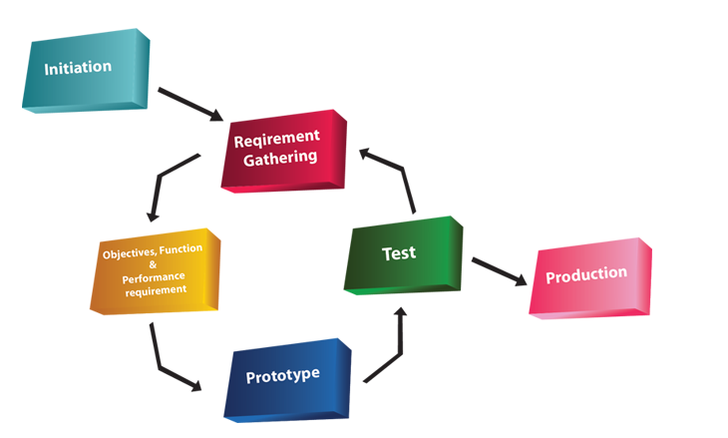The project can have different ways of operating. One way in which the group can implement the project is by the Prototyping SDLC model [6]. The Prototyping model allows the team to work concurrently on three aspects of the SDLC, them being the analysis, design and implementation. This model is on a constant loop until a finished product is completed. The prototyping model is a very fast paced model but allows us to interact with the application more to gain a better understanding of its functionality or areas of improvement that might not have been foreseen with other model approaches.

Figure 1‑1 - The Prototyping Model

## Proposed Methodologies

This is a three person team. Each team member will have a defined role, based on our abilities, strengths and interest of self-learning. Throughout the development, every member of the team will be brought up to speed on the progress of each of the other members. The aim is that all members are proficient with all aspects of the project.

### Member 1

This member’s responsibility will be to front the programming side of the project, with the objective to use numerous technologies to work concurrently. This application will use Android SDK [7] to develop the web front for all Android devices which run Froyo 2.2 [8], or newer. With the aim of the app being compatible with 100% of all Android devices, Android’s WebView kit will be used. The next step will be to develop responsive pages with the use of an open source CMS such as WordPress to manage pages.

### Member 2

This member will focus on the security issues which may arise with relation to user log in and registration. This involves an extensive amount of research into current hacks and security issues on the market. There is a need to obtain self-signed certs which will be sourced early in the project [9] [10].

There will need to be high-end security measures to ensure that data protection is adhered to for all players, concentrated around the user registration and login.

This member will also assist in the layouts and the look-and-feel of the application

### Member 3

This member will target the graphical user interface. The main objective is to develop a smooth and an aesthetic application which will encourage return customers and customer growth. Development of custom imagery for the application will be established using tools such as Adobe Illustrator, Adobe Photoshop and GIMP.

### Member 4

At the mid-point of development, it was proposed to initiate a fourth member to the team. This member’s primary responsibility was to develop an extensive and in-depth testing system. Using Unit Testing, this member will challenge the application source code to identify any vulnerabilities which exist, which will in turn help eliminate any flaws which may not be recognised until the application is released for beta testing.

There will be a separate chapter dedicated to this category later in the documentation which will include a log of all the tests, their functions, the expected result, the actual result, and any recommendations or changes made to the code to ensure test passing.

### Group Elements

The team will develop a-state-of-the-art modern, ‘hi-res’ graphics using animation tools such as Adobe Illustrator, Photoshop and GIMP. There is a possibility to use Dreamweaver for transitions.

PhP scripting will be used to consolidate all elements of the application resulting in a smooth application with a modern and fun look’n’feel.

For hosting, the team has secured permission from Absorb.ie to have full use of their servers inclusive of a sub-domain and installation of third-party utilities. [11]

A SQL Database table will be used to contain all questions needed. A second SQL database table will be vital for the storing, accessing and modifying of user login, registration and sessions. These tables will be generated using PHPMyAdmin MySQL.

## Application

The application will be a cross between a game and a quiz. Whilst having the academic functionality of an educational quiz, it will have a young, fresh approach to learning. For this project, the subject matter will be on networking terms and concepts.

The application will consist of three levels. A description of these levels is detailed in the next section.

### Level 1

The first level will be easy, containing definitions and abbreviations on an MCQ basis. One question will have 4 possible answers with only one answer being correct. There is plans to have a pool of 300 questions for the finished product. However, for the sake of this project, it is more feasible to run a beta model with a pool of 10 question.

### Level 2

The second level is more difficult. Questions will be based on exam quality definitions and networking syntax on an MCQ basis. One question will have 4 possible answers with only one answer being correct. There is plans to have a pool of 300 questions for the finished product. However, for the sake of this project, it is more feasible to run a beta model with a pool of 10 question.

### Level 3

The third level is the most difficult. Questions will be based on the general theory associated with networking on a CCNA level. Each question will be answered textually. This will involve technology which will recognise keywords and strings. There is plans to have a pool of 150 questions for the finished product. However, for the sake of this project, it is more feasible to run a beta model with a pool of 10 question.

### Player advancement through levels

In order for the user to move from one level to another, the player must answer ALL the questions in each level. If a question is answered correctly, that question will be flagged ‘true’. If question is answered incorrectly, the program generate next question. The wrong question remains in the cycle until it is answered correctly. All questions are generated randomly.

## Deliverables

The aim is to have a fairly established running BETA model by Christmas break which will leave the next semester for testing and defining our documentation.

In this section, the expected results are examined in order to identify any issues before the project officially begins.

A Work Breakdown Structure and Gantt-Chart, which follow, provide a condensed and visual view at the tasks and predicted timeline of the project.

### Expected Results

1. A fully functional Android application.
2. A young, dynamic, fun and educational tool for learning networking fundamentals.
3. A knowledge and understanding of Android development.
4. Implement a new knowledge of security protocols and risk in regards to Android development, focusing on the data protection of users.
5. Learn to combine different languages and technology to ensure an ergonomic and efficient application.
6. Gain experience in the area of teamwork and learning to approach intrapersonal issues.
7. Development of an application which has the potential to be adapted to other academic topics.

### Work Breakdown Structure

1. Proposal
2. Research possible technologies required
3. Secure supervisor
4. Research existing applications
5. Research forensic measures required
6. Establish all software requirements
7. Risk analysis 1
8. Develop GUI
9. Develop Database
10. Establish BETA model
11. Risk analysis 2
12. Finalise responsive elements
13. Implementation
14. Testing

### Gantt-Chart

This chart shows the division of labour among the development team. It is subject to change.

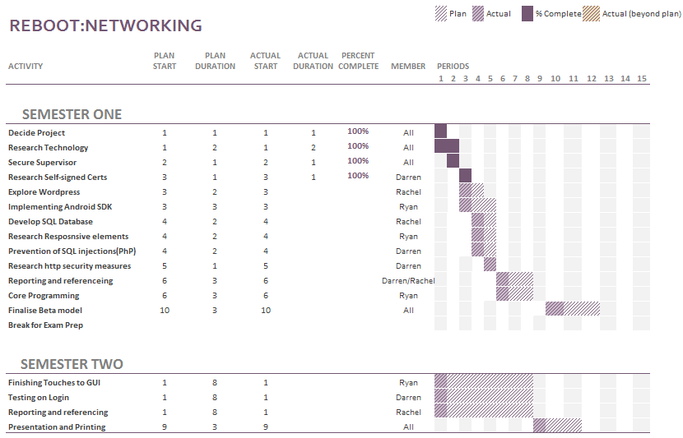

Figure 1‑2 - Gantt-Chart

## Planning Review

This application, as it stands, is available and ready for development to begin. A feasibility study will show any changes that may need to be applied. The title and structure will be re-investigated at regular intervals throughout the duration of the project in order to improve the efficiency of the development build.

This product has great potential as it can be expanded in size by merely extending the database. This product has the potential to be phased into other educational areas such as Mathematics, Data Structures, Operating Systems and many more.

The technologies that will be used are openly available and the deadline has been set to ensure the productivity of the project is high.

The team has agreed to dedicate to a tight deadline of March 2016. This will give enough time for testing and allow for any contingency plans to be used if needed.

# Literature review

This chapter contains various investigations with regards to the diverse views of this project. Each member of the development team took a separate segment and researched and reviewed literature which supports one aspect of the overall project.

Review A: Is a multiple choice quiz (MCQ) an efficient and effective format of assessing students?

This review is an investigation into the attitudes and finding with regards to the significance and reliability of multiple choice quizzes (MCQ) in the assessment of academics.

Author: Rachel Egan

Review B: How the implementation of multiple choice questions on mobile devices for 3rd level students can aid in their subject of choice.

This review take a secondary look into the value of using MCQs as a form of assessment for students with particular emphasis on the medium of presentation. This section investigates the importance of convenient access to assessments with immediate feedback from the viewpoint of the assessed. It continues by exploring the various strategies and technologies that can be used to achieve optimum results.

Author: Ryan Mackenzie

Review C: A research in to the technology to be used in the development of an educational application with the subject of Computer Networking

The focus of this review is to show all of the technologies that will be used in the making of our application. With computer networking growing and becoming more and more complicated by each passing years, more and more technologies are needed to improve the accessibility to the practical use of it.

Author: Darren Cosgrave

## Review A: Is a multiple choice quiz (MCQ) an efficient and effective format of assessing students?

The specific topic of this research is to support, or disparage, the general opinion on using a multiple choice quiz (MCQ) as an efficient and effective format of assessing students.

“In ancient Greece, Socrates tested his students through conversations. Answers were not scored as right or wrong. They just led to more dialogue.”[12]

Over time it has become more apparent that academic testing, especially in the field of science, has become more standardized and in recent years the format has drifted from the essay style testing. The emphasis has shifted towards what the student can recognize, rather than what the student can memorize.

This document is designed to represent both sides of the argument, using accredited sources and a range of beliefs.



Figure 2‑1 - An example of a Multiple Choice Quiz

### Where MCQ testing came from

The attitude regarding multiple choice testing in current academic settings has been argued since the early 1900s when the first evidence of standardized testing was introduced. This is very apparent in the article by Jay Mathews, a staff writer for the Washington Post in 2006 on the subject of how testing students has evolved over time.

Mathews’ article provided a fact-based delivery of the formation of general testing in the United States from the time of Socrates to the time of publication. In this article, he discussed how the progression from essay style testing started to be replaced by the MCQ style around the turn of the 20th century.

*“At the outset of the 20th century, educators began to experiment with tests that took shortcuts around the old essay methods….Frederick J. Kelly of the University of Kansas designed a multiple-choice test in 1914…..Many Americans accepted these tests as efficient tools to help build a society based on merit, not birth or race or wealth.”[12]*

The philosophy surrounding that seems to be speed, both for student and examiner, and accuracy. It was developed with the ethos that students who had difficulty with the focus and drive needed for succeeding academically had a chance to be pitted against those students who found memorising theory less challenging. Multiple choice testing also ensured that all participants were tested on a level playing field without judgements which may arise from the student background or circumstances.

Since the development of the first MCQ, Frederick J. Kelly’s model has not been altered much. The basic structure and objective of the test is simple and relatively unflawed (see figure 3)

### MCQ - an effective format for testing?

There have been many arguments in the philosophy of testing in education, for and against.

One person who took an adverse opinion to the multiple choice format for the purpose of academic testing was Diane Ravitch, a historian of education with a Ph.D. from Columbia University. In an article she wrote in “The Chronicle of Higher Education” in March 2006, Ravitch was unimpressed with the lack of essay style testing, especially in the more scientific subjects such as Medicine and Information Technology.

Commenting on the early use of essay exams in the United States, Ravitch wrote "everyone who went to high school, whether they were the children of doctors or farmers or factory workers . . . to study mathematics, science, English literature, composition, history and a foreign language“ [13].

Cathy N. Davidson’s is a distinguished scholar of the history of technology and is a leading innovator in techniques for new professional development and learning methods. She was recognised for her expertise and appointed to the National Council on the Humanities by U.S. President Barak Obama in 2011.

As a reputable speaker and consultant, Davidson is a regular writer for the Harvard Business Review, The Chronicle of Higher Education and The Washington Post.

In her book, “Now You See It”, Ms Davidson expresses her appreciation of Kelly’s theory that multiple choice testing is an efficient method of testing in a scientific academic situation. She agrees that in order to make a test both objective and efficient, questions need to be formulated without ambiguity. Questions must have an answer that is completely right or completely wrong, with no variable interpretations.

*“What the multiple-choice test did avoid, though, was judgment. It was called objective, not because it was an accurate measure of what a child knew but because there was no subjective element in the grading.”*

*Cathy N. Davidson [14]*

Multiple choice questions are considered to be more objective than traditional essay methods as the facts are measured and not the individual opinion. This is a positive for both learner and educational provider for only one answer is right. This ensure that even if opinions vary, any interpersonal differences will not influence the results.

MCQs allows student knowledge to be measured without the challenge for assessors to read handwriting, or understand an answer which has been written in an exam situation where students may not express themselves clearly.

The general consensus in academic circles is that MCQs are regarded as an efficient form of assessment in medicine and the sciences, but in subjects such as humanities, it is viewed as mcq as a ‘dumbing down’ version of learning. The following section highlights some of the advantages and disadvantages of using multiple choice quizzes for assessments.

### Advantages and disadvantages of using MCQs as a method of testing

In the book, “Computer-assisted assessment of students” by Brown et al, the authors and contributors highlighted many advantages and disadvantages of using MCQs as a method for assessing current students [15][16].

Advantages include the following.

1. MCQs are easy to convert to computer based format.
2. Require much less time to construct.
3. Require much less time to complete.
4. Student tested on ‘recognizing’ rather than ‘memorizing’.
5. Fast return of grade for students.
6. No subjectivity if student is vague in knowledge.
7. Answer is right or wrong…..no discrepancies!

Disadvantages include the following.

1. For more specialized subjects, the complexity of questioning makes MCQ construction time-consuming
2. They do not measure performance in complex areas
3. They do not measure students practical knowledge
4. Students can ‘guess’ a way to success

It is obvious that there is a difference of opinion with regards to the effectiveness of multiple choice quizzes as a form of assessment. However, everyone can agree that MCQs are objective. There is little or no variations in marking, they are easy to mark, they offer immediate feedback, and they test the students’ factual knowledge without prejudice.

In the next section, the author will provide an unbiased comparison between essay style and multiple choice style assessment.

### Essay Exams verses Multiple Choice Quiz

Mark G. Christensen, Ph.D., Assistant Executive Vice President and Director of Testing for the National Board of Chiropractic Examiners (NBCE) attended the CLEAR Annual Conference in Phoenix, Arizona, USA. During this conference, Christensen delivered a presentation on the similarities and differences between essay based examinations and multiple choice quizzes. A synopsis of his delivery is presented in the following table [17] [18].

*Table 1: Essay vs Multiple-choice*

|  |  |
| --- | --- |
| Essay Exam | MCQ |
| Quick and easy to construct test | Quick and easy to construct test |
| Answers allow for expansion of thought and understanding on a certain topic | Answers and either right or wrong. There is no room of subjectivity |
| Student must provide answers without prompting | Answers are provided allowing students to guess a way to success |
| Labour-intensive and time-consuming to grade | Immediate grade with little to no labour |
| Can lack objectivity | Grading is objective and completed reliably |
| Assesses the students overall knowledge of the subject matter | Assesses the students ability to recall snippets of knowledge through recognition |
| Measures limited amount of knowledge in an individual test | Questions can cover a vast array of knowledge in a short time |

Christensen is highly regarded by his peers. In his 30 years working with NBCE, he has designed and implemented a testing program for the chiropractic profession which has been adopted by many scientific academic fields around the world. Acceptable methods for assessment comprises the use of written, practical and multiple-choice testing [19].

### Conclusion

The aim of this document is to discover if multiple choice testing is an efficient and effective method of assessing students. The research resources are endless on this topic, and each argument is convincing in its own right.

As a student, it is easy to side with the argument for using multiple choice quizzes for assessment. However, when the full picture is taken into consideration, the author can appreciate that MCQs can miss the target when testing the human understanding of the subject matter.

While there is certainly a time and place for MCQ testing, there is serious validity to essay style exams too. For a more in depth look into the design of MCQs, David Jennings, a published lecturer and researcher in UCD, Ireland, wrote 'A Problem and an Opportunity: E-Learning a case for collaboration' to help outline the “do’s and do not’s” of MCQ construction [20].

Multiple choice assessments have been around since 1914, thanks to Mr. Kelly. Its longevity is proof that it is as valid an assessment method in current academic setting as it was a century ago.

## Review B: How the implementation of Multiple Choice Quizzes (MCQs) on mobile devices for 3rd level students can aid in their subject of choice.

In this section, it will be discussing how existing research papers and developments have contributed to the area of study with regards to the use of MCQs in an academic environment. It will be considered how MCQs have been developed and used over time, as well as the fundamental alternative forms of learning amid theoretical assessment and MCQs.

The primary focus of this section is to identify how Android devices and web-based services can be used to provide a platform for E-learning and M-learning in current educational models.

### MCQs – are they used?

As discussed in the previous review, MCQs have been a universal method of assessing students for a substantial period. They are prevalent in a variety of educational institutions with evidence in the majority of 2nd and 3rd level education providers.

Dependant on the subject format, MCQs can take on varying shapes. Traditionally, the layout of an MCQ has followed a ‘one question, one answer from a selection of four possible answers’.

MCQs are generally found in a surface approach to education, where a student is required to recall information based on the resources they have studied. However, some students prefer to take a deep approach to education which is based primarily on practical learning. This latter approach does not necessarily leave a student at a disadvantage with regards to MCQ assessments as the student can recognise the majority of concepts with a reduced chance of error.

K. Tang, a Chinese professor, conducted a study where first year physiotherapy students, when preparing for their examinations, took a surface approach to their assignments. Conversely, when it came to examinations took a deep approach, which is a more intensive approach to learning. This quantitative study demonstrated that students tend to employ different learning approaches or strategies in different situations, according to their perception of the assessment requirements. Students are likely to adopt a surface approach to learning if they anticipate a form of assessment that requires little more than knowledge-based factual recall (e.g. a quiz, multiple-choice questions or a short answer examination) [21].

In a paper by Karen Scouller, she provides research by Proseser, Thomas and Bain which reads

*“…two studies investigating the relationship between student’s learning approaches and performance outcome in their MCQ examinations and both using a quantitative measure of student achievement (MCQ examination marks) have reported different findings. They reported a strong relationship between successful performance and deep general orientations to study (Scouller and Prosser 1994) and between better grades and the employment of a deep level approach (Thomas and Bain 1981; reported in Watkins 1982). This study similarly uses quantitative measures of student achievement: students’ assignment essay marks and their MCQ examination results.”* [22]

This describes how MCQs have been shown to match, if not exceed, the results that come from written examinations.

There are many difference between MCQs and written assessments. The most notable variance is that a written exam is more costly on time when it comes to the exam being constructed, and subsequently, graded. In contrast, an MCQ can be generated using databases linked to MCQ generators. The most obvious difference is that when an MCQ has been developed, it is easy to manipulate and regenerate, as well as giving an almost instant graded result if the MCQ has been utilised digitally.

As discussed in the previous review, written exams are high in work intensity requiring students to regurgitate large quantities of information, with grading potentially being subjected to a lack of objectivity.

### E-Learning and M-Learning

Electronic Learning (E-Learning) can be defined by the Oxford Dictionary as

*“Learning*[*conducted*](http://www.oxforddictionaries.com/definition/english/conduct#conduct__8)*via electronic media, typically on the Internet” [23]*

E-learning makes it possible for students to study using computer technology. The main advantage of this the freedom for self-disciplined learning as opposed to being required to always physically attend classes. E-learning is a relatively new system which is becoming common practice for a wider range of students such as people with disability, parents and those in full-time employment. Open University™ was founded in 1964 by British scientist, Michael Young, Baron Young of Dartington, to offer education to those individuals who could not physically attend lectures [24]. The Open University™ offers a vast array of online courses with the added advantage of flexibility and less costly to the student.

When merged with more recent technology such as smart phones and tablets, E-learning has become extremely accessible and efficient. In the paper “Implementation of Android Based Mobile Learning Application as a Flexible Learning Media” by Kurniawan Teguh Martono and Oky Dwi

Nurhayati, they summarize M-Learning as follows:

“Mobile learning as an intersection of Mobile Computing and E-Learning providing resources that can be accessed in anywhere has capability in an excellent searching system, rich interaction and full support towards an effective learning and performance-based assessment. In addition, it has a characteristic of not being dependent on time and space. Education requires an alternative learning model typically not dependent on time and space. It is also expected that the alternative model can facilitate knowledge sharing and knowledge visualization in order to make knowledge more interesting and easy to understand.” [25]

### Technology in study

Technology is currently playing a huge part in today’s society where everything is considered ‘smart’ and there is a vast amount information at our fingertips. The Internet of Things (IoT) is going be a phrase that we hear used quite bit. It refers to everyday objects having network capabilities and transmitting data as well as receiving data, such as smart phones, smart refrigerators and smart watches [26].

It is believed that by 2020 that there will be 50 billion devices connected to the internet as reported by Jonathan Strickland [27] a leading member of staff at www.howstuffworks.com. This supports the argument of utilizing technology in order to learn and vice-versa how technology can learn from us. 3rd level students use laptops, computers, tablet computers and smart phones all on a daily basis either to access social media platforms, games or educational tools, this is best summed up by Stan Kurkovsky’s abstract to which states:

“Young people are often viewed as the driving force behind the innovation in mobile technology, since they comprise the majority of early adopters and most avid users of mobile gadgets and applications, especially mobile games. Many contemporary college students grew up surrounded by computer games and electronic gadgets and, therefore, may better relate to mobile technology than to the desktops dominating current academic environment.” [28]

In the paper Kurkovsky mentions how, in the opinion of today’s college students, there is a serious under-use of current technology with regards to E-learning, despite mobile interaction often having a much more entertainment-orientated value. Kurkovsky also references a study by IBM released in October 2008 in which over 50% of consumers in the United States would prefer to use their mobile devices over PC’s for their internet usage, this was taken from an age group of 15-30 year olds.

Technology in study (e-learning) on mobile devices can, not only provide a valuable research component for the students to gather information and study, but it can provide a platform in which students can access this information on the move whether they are on public transport, in a coffee shop or out of country.

Considering that mobile technology is already prevalent in the lives of college students, by developing an application such as this MCQ game that can test their knowledge as well as provide a fun and interactive way of learning, it is a remarkable gain for the student. It can also benefit that of the educator with the existence of applications such as “Socrative” [29]. This application provides a venue for educators to host a quiz and provide real-time results of students’ knowledge priceless information by highlighting levels of knowledge and understanding of each segment of the module.

### Web Services for Mobile Learning Applications

Mobile learning applications are constantly being developed on different technologies and platforms such as iPhones IOS, Android’s APK’s, Windows Phone and Linux. Paul Pocatilu PhD has completed several research papers bases on the elements involved in developing and maintaining Mobile Learning [30].

An M-learning system has minimum specifications and must consist of the following components:

* Mobile learning device
* Mobile learning software
* Mobile learning content

Pocatilu also mentioned the actions students can take when it comes to the m-learning system:

* Take online course
* Take exam
* Send feedback
* Send homework and projects

Pocatilu outlines his opinion on educator involvement and the tools that they should have:

* Deal with content management
* Prepare tests
* Assess test, homework, projects take by students
* Send feedback
* Communicate with students

There are many web services that can provide hosting and tools that can further help with the development of mobile applications. Web hosting allows for a global communication across all platforms. This means that if a multiple choice question is hosted online, the application is compatible to run on an iPhone with the same precision as on an Android system.

### Conclusion

When measured against traditional written assessments, multiple choice quizzes have repeatedly proved to be the paramount form of assessment in most educational fields. This review also highlights the benefit of pairing mobile technology with the format of MCQs to encourage and engage students.

The way in which students interact with these quizzes can have a fun yet beneficial impact on their education. Not only can it benefit the academic but it can also benefit the educator in a way that it can improve learning plans as well as monitoring individual performance.

## Review C: A synoptic review in to the technology to be used in the development of an educational application with the subject of Computer Networking

In this section, the technology available for the development of this project is explored. A brief synopsis of these technologies is offered. The technology covered in this investigation includes Java, JavaScript, PhP, HTML, CSS and Android.

### Java

Java is a general purpose programming language that was developed at Sun Microsystems by James Gosling. In 1991, a small team of engineers created the language “O.A.K” to help in the development of handheld devices and set-top boxes. When this failed, they went back to the drawing board. In 1995, Java was created. The language itself follows some of the basic rules of its competitor, C and C++, but the syntax and functionality was unique and expansive, with a lot of room for further expansion [33].

These days, Java is used mainly as a foundation in the development of web-based applications and services. Its usage in mobile technology has climaxed in the past 6 years, with advancements in the language. In 2014, Java SE 8 was launched. This version carried additional functional programming features, improved integration with JavaScript and parallel processing using streams.

Java is object-oriented modelled on C++, but it is simplified to eliminate common programming errors. Compiled Java code can run on most devices because Java interpreters and runtime environments exist for most operating systems, including Windows™ and Unix™. By 2007, most Java technologies were released under the GNU General Public License.

Java is most renowned for its use on the World Wide Web. Java applets are easy to download from a Web server and can be run on a Java-compatible Web browser. It is common to have Java as an automatically installed program on most new laptops and PCs.

### PHP

PhP originally stood for Personal Home Page but stands for PHP: Hypertext Pre-processor [34]. PhP is a server-side scripting language designed for web development but also used as a general-purpose programing language. Developed by Rasmus Lerdorf in 1994, early versions of PhP were not intended to be a new programming language but as it grew larger and larger, a development team began to form and improve the code quality making it more powerful from PhP3 to the current development of PhP7. The latest version is expected to be released in November 2015[[1]](#footnote-1).

Over the years PhP has improved and has gained momentum every day. As you can see in fig 1 it show that more and more users using PhP, from January 2000 to March 2005

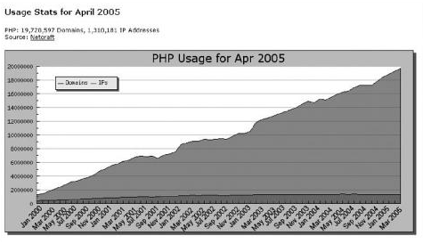

Figure 2‑2 - A graph to show the steady rise in the usage of PhP since January 2000

<?php

if(isset($\_POST['username']))

{

$username = $\_POST['username'];

$password = $\_POST['password'];

// require\_once("include/db\_connect.php");

require\_once("config/db.php");

// $db\_link = db\_connect("majorgroupproject");

Figure 2‑3 - Example of some PhP syntax

### HTML

Developed by Tim Berners-Lee in the late 1980s, HTML is an acronym for Hypertext Markup Language.

“Web users ultimately want to get at data quickly and easily. They don't care as much about attractive sites and pretty design.”

Tim Berners-Lee

HTML is, essential, a set of markup symbols inserted into an electronic file that will be displayed on the World Wide Web via browser pages. Each individual markup symbol is commonly referred to as a “*tag”* or element.

Its logical structure permits intelligent information processing which is necessary for organisation, communication, indexation and discovery on the web. The added benefit of HTML is that it supports the translation of audio, video and animation into an electronic document by using software such as Java applets, QuickTime or ActiveX.

The latest version HTML5 was released on 28th October 2014. However there is always new and improved ideas being developed and tested with vast improvements being made to advance the user experience in web design and development.

have brought out there new HTML5 on 28 October 2014 [35].

<!DOCTYPE html PUBLIC "-//W3C//DTD XHTML 1.0 Transitional//EN" "http://www.w3.org/TR/xhtml1/DTD/xhtml1-transitional.dtd">

<html xmlns="http://www.w3.org/1999/xhtml" xml:lang="en" lang="en">

<head>

<!--<meta http-equiv="Content-Type" content="text/html; charset=utf-8"/>-->

<meta name="viewport" content="width=device-width, initial-scale=1">

<title>About</title>

Figure 2‑4 - Example of some HTML

### CSS

CSS is an acronym for Cascading Style Sheets. It is a style language that defines layout of HTML documents. It is responsible for formatting structured content which includes fonts, colours, margins, backgrounds, lines and advanced positioning [36]. CSS was developed by Håkon Wium Lie and Bert Bos and introduced in 1996.

CSS revolutionized the world of Web Design by allowing developers to manage the aesthetic aspects of the website from one stylesheet.

body{

background-color:#C3C3E5;

}

#title{

color:white;

font-size:18px;

padding-left:10px;

}

Figure 2‑5 - Example of some CSS syntax

### JavaScript

JavaScript is a programing language used in web development. Developed by Netscape, JavaScript is used to add dynamic and interactive elements to a website. JavaScript is influenced by java and c. JavaScript is a client side scripting language which means source code is processed by the user and not the server. Due to this JavaScript can run after a web site has loaded without internet connection to the server [37].

Figure 2‑6 - Example of some JavaScript.

This is the JavaScript used to develop the contact form on the application.

<a id="foxyform\_embed\_link\_769550" href="http://www.foxyform.com/">foxyform</a>

<script type="text/javascript">

(function(d, t){

var g = d.createElement(t),

s = d.getElementsByTagName(t)[0];

g.src = "http://www.foxyform.com/js.php?id=769550&sec\_hash=97a87424aa7&width=350px";

s.parentNode.insertBefore(g, s);

}

(document, "script"));

</script>

### Android

Android is an open source operating system used for mobile devices. It is currently developed by Google™ and its programming is based on the Linux™ kernel. It was primarily designed with advancement in touchscreen technology in mind and that has transpired into fast-track developments in smart phones, smart televisions, smart watches and tablets, to name just a few.

Due to Android being open source, developers can modify and change the OS for their own preferences and styles. This is further enhanced by the fact that the ordinary person can self –learn and develop simple applications using accessible and widely available IDEs. As a result, the market is flooded with amateur applications for absolutely everything. But it still is a developing field, so there is plenty of room for all participants.

Android’s user interface is based on direct manipulation, using gestures such as *touch, swipe, pinch or tap* to access or move objects on the GUI (Graphical User Interface).

As of February 2016, Android 4.4 "KitKat" is the single most widely used Android version, operating on 35.5% of all Android devices accessing Google Play. The second most popular is other Lollipop versions (5.0-5.1.1) which has a combined total of 34.1% of the user market [38].

“Marshmallow” is the newest release and was launched in October 2015. It is slowly building momentum and is expected to replace all other versions by mid-2016.

### Bootstrap Framework

There are many advantages to using Bootstrap. The following identifies some of these advantages and how Bootstrap was used to implement certain aspects of this application [39].

#### Flexibility and Responsiveness

Bootstrap is a flexible framework as it can work on multiple platforms. This allows any program developed using Bootstrap to be compatible with the majority of devices on the current market. It is also renowned for being user-friendly. With the built-in tutorials, even an amateur can learn how to use Bootstrap to its fullest extent. The instructions and functionalities are logical, and most of the necessary actions open source and therefore accessible.

Bootstrap make use of certain HTML5 doctype properties which offers a better quality of resources.

#### Mobile First

Bootstrap v2 contained optional mobile friendly styles. However, with the introduction of Bootstrap v3, mobile functionalities can be implemented from the beginning of any project. This has been a key development as most all online activities are application based, or have an application attachment.

<meta name="viewport" content="width=device-width, initial-scale=1">

Figure 2‑7 - Code to ensure proper rendering and touch zooming

#### Typography and links

Bootstrap sets basic global typography, display and link styles. Essentially this translates as it is easy to manipulate background colours, fonts, lines, padding and manipulation of other features such as a colour change only on a hover function of a link.

### Conclusion

As presented in this review, there is an extensive range of technologies and programming languages involved in the development of this program. These elements must work together in harmony and compatibility is always a concern.

For this project, the team was already familiar with using Eclipse as the IDE for the majority of the programming as it is compatible with HTML, PhP, CSS and Java.

It is important to use versions of the software which will co-exist with newer and older devices so that most all of those wishing to use this application, the software is accessible to them too without monstrous expense or the need for a large amount of memory in the user device.

# Implementation

## Code Structure

After design planning, it was obvious that this development would use the Abstract Factory design pattern. Contained in this abstract pattern are certain implementations of the Façade pattern. These are apparent in the development of the “Settings” functions. When the user chooses the “Change Username” button, the program is directed to a hidden class which runs the alterations. This is true for the other buttons in the “Settings” list.

## Data Schema Design

This application has need of only one database and one database table. Initially, it was arranged to have a four tables, one for each of the three quiz level, and a fourth for the users.

However, when reinvestigated, it was noted that the better option would be to have one table for the users only. The questions and answers were now to be rendered through the use of a JSON file.

The score updates are stored to the user table. This was purposely designed this way to avoid database rebooting and reduce the number of queries necessary for smooth running of the program. By using the technology in this way, the application became less reliant on the database, thus avoiding numerous potential glitches after product release.

The technology used for the database was supported by PHPMyAdmin which is accessible and open source [40]

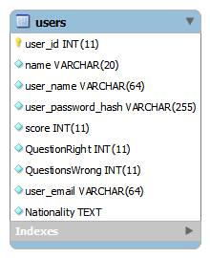

Figure 3‑1 - ERD for the User Database Table

# Design

## User Interface Design (Wireframes)

|  |  |
| --- | --- |
| 1. Home page   C:\Users\Rachel\AppData\Local\Microsoft\Windows\INetCache\Content.Word\1.home.png  Figure 4‑1 - Home Page | 1. Dropdown Menu on the Home Page   Figure 4‑2 - Dropdown Menu on Home page |
| 1. Sign Up Page   Figure 4‑3 - Sign Up Page | 1. Account Issues From Login Page   C:\Users\Rachel\AppData\Local\Microsoft\Windows\INetCache\Content.Word\4. accountIssuesFromLoginPage - reset account.png  Figure 4‑4 - Account Issues From Login Page |
|  |  |
| 1. Main Menu   Figure 4‑5 - Main Menu | 1. Settings   Figure 4‑6 - Settings |
| 1. Change Language   Figure 4‑7 - Change Language | 1. Quiz   Figure 4‑8 - Quiz |

The wire framing was generated using an online tool at *www.wireframe.cc* [41].

## Colour

For the purpose if this application, the development team decided that the colours used could play a large part of successfulness. After some research, it was decides that purple was a strong choice.

The colour scheme had to be attractive, as well as psychologically sound. Therefore, it was agreed that the main colour would be mauve, while the application would have trims of amethyst.

Although this may seem a frivolous aspect of the overall project, colour is regarded as a form of none verbal communication. Colour choice could make the difference when trying to generate repeat customers. An application is only as successful as what its audience makes it.

Together with the idealism of aesthetics, there has been vast studies into the effects that colour has on the brain. In the field of psychology, purple is recognised for its combined attributes of red and blue. Red signifies fire, motivation and power while blue creates a calm, bright atmosphere. By combining these values, there is a greater chance to promote an academic, resourceful environment for the user [42].

For the purpose of this application, the development team selected mauve and amethyst.

### Mauve

Mauve falls somewhere between lilac and lavender in the purple spectrum. It is recognised to promote best choice and decisions with humans while encouraging a person to do the right thing. Mauve has also been noted for creating a sense on commonness and the will to improve oneself. This can be beneficial to the attractiveness of this application by encouraging users to aim high with the best choice in the forefront of their goals.

### Amethyst

Amethyst is regarded as a mystical colour. It can stimulate deeper thinking and rational decision making. For this application, the users are subconsciously guided towards a logical, and correct, answer. This also allows the user to recognise errors in their choice for further use [43].

### Logo

C:\Users\Rachel\Desktop\3rd yr project\logoTransparent\logoTransparent.pngWith regards to the logo, it has been proven, by the sheer volume in existence, that blue is the most common colour to use when developing an application logo. For this reason, the team came to the conclusion that we needed a strong, yet recognisable, colour for our logo.

Figure 4‑9 - Logo

“Chase, American Express™, and IBM™© choose blue because the colour suggests trust, strength and dependability” [44]

This source image for Boombastics™ ReBoot: Networking was designed by two members of the team. It symbolises the idealism of networking on a global scale being connected with a cable in the shape of the infinity symbol. This emphasises the fact that the topic of computer networking and the learning associated with it is endless but can reach extensive levels

This logo uses blue as its primary colour. Looking into the world of colour psychology, blue is used for many applications as it represents loyalty, justice and perseverance as it is in the American flag. It is also recognised as being a masculine colour while offering subconscious feelings of being comfortable and nonthreatening. According to an article on inspiredology.com.

“The color blue is considered to be nonthreatening yet instill confidence. In addition, it’s a traditionally masculine color, so it’s no surprise that it also evokes ties to the corporate world” [45].

## Layout

When this project was planned, it was considered best choice to use JQuery’s to manipulate the CSS throughout the software.

On further investigation, it was apparent that by using Bootstrap, the development was going to take a new direction. Bootstrap was the obvious choice for what was intended for this application.

### Animation

There is a vast pool of JavaScript which favour a Bootstrap framework when implementing animation.

The first step was to discover what trends are in existence. After all, if it has been proven to work in the past, and it is popular, then it is safe to say that it is advisable to use these common trends.

To assist this development, open source JavaScript and CSS was used. The resource which demonstrated itself to be most appropriate for the application development was provided by Daniel Eden, a first class graduate of Nottingham Trent University in Digital Media Technology. Eden is currently a design engineer in Dropbox, San Francisco, and is currently developing “Scooter” (SCSS framework). Eden developed a site based exclusively to animations, aptly named animate.css [46].

Another resource from developer.mozilla.org was used to support the development of the animation [47].

#### *fadeInLeft* animation which was used when loading buttons onto pages

A simple *div* tag with the *fadeInLeft* animation. Whatever is placed inside of the *div* will adopt a fade in from the left side of the GUI. For example, <p> <h1> or <button> tag will react to the fadeInLeft animation syntax.

Figure 4‑10- Syntax for fadeInLeft JavaScript

<div class=”animated fadeInLeft”>

#### *transition* animation between pages

When the user clicks a button it will initiate an *onclick()* function and will pass in a value such as “quiz” into the function. The animation will run and *redirect* will wait 0.8 seconds to give a slick and neat movement.

Figure 4‑11 - Syntax for transition JavaScript

function transition(pageName)  
{

//anything in container will fade out right  
document.getElementById('container').className = 'animated fadeOutRight';

//nav will fade out up document.getElementById('nav').className = 'animated fadeOutUpBig';

// wait for 0.8 of a sec

setTimeout(function(){window.location.href=pageName;},800);

}

Button for “QUIZ” with the *onClick()* function that will call the above function

Figure 4‑12 - Syntax for onClick function

<button type = "button" class = "btn btn-primary btn-lg btn-block" id="button\_color" onClick="transition('quiz.php')">

Quiz

</button>

#### *fadeInDownBig* animation on header

The nav bar is being loaded in with PhP and is in a *div* tag which has a *class id* of *fadeInDownBig*. (Z-index and position was used to stop the logo from coming up when you expanded the nav bar on mobile)

Figure 4‑13 - Syntax for fadeInDownBig JavaScript

<div class=”animated fadeInDownBig” style=”z-index: 99; position: relative;”>

<?php include ‘include/header.php’;?>

</div>

#### *Flip* animation on the logo

Figure 4‑14 - Syntax for animating a flip motion on logo

<img src=”images/icon.png” class=”animated flip” id=”user-default” width=”200px” alt=”company logo”>

#### *Bounce* animation on the main headings

Figure 4‑15 - Syntax for animating a bounce on main headings

<h1 class=”animated bounce”>About</h1>

### General Layout

#### Header

This PhP file contains the navigation bar for the application. For security purposes, it was decided to formulate two alternative navigation – one for logged in users and another for public access.

When the user is logged in

The user has access to log out.

When the user is not logged in

The user has access to register a new account

Universal settings

Each navigation bar has access to the home page, about page, contact page and T&Cs (Terms and Conditions).

#### Dropdown Menu

This PhP file is included in the header.php file. It invokes a different format depending on the dimensions of the device. On a standard laptop, with the dimension 1024 x 768 px, the navigation is displayed as a navbar. However, when the application is loaded on an iPhone5, dimensions 320 x 568 px, the navigation appears as a collapsible tree. This is achieved using the following syntax.

Figure 4‑16- Syntax for collapsible nav bar

echo '<div class="collapse navbar-collapse" id="bs-example-navbar-collapse-1">';

#### Footer

This PhP file is universal to all main administrative pages. It contains links to T&Cs PDF file, Privacy Policy PDF file, copyright tag and year of publication.

#### Logo

This source image is nested in to the Home page and Main Menu page. The logo is also used for the favicon in web view.

#### Buttons

To add depth to the application pages, it was thought that adding shadow and shade to the buttons would give the impression of height. To compliment the Bootstrap buttons, CSS was used to incorporate a grey coloured shade using the following syntax.

Figure 4‑17- Syntax for button shading CSS

box-shadow: 10px 10px 5px #888888;

#### Quiz page

The quiz page is constructed with three main HTML5 <div> tags.

1. This is used to read and retrieve the data for the questions and answers from the database.

Figure 4‑18 - i. "questions"

<div id="questions"></div>

1. This enforces a check that the user must submit an answer to all questions before moving forward in the quiz. If no answer is submitted, an error message is displayed to the GUI (Graphical User Interface).

Figure 4‑19 - ii. "error"

< div id="error"></div>

1. This <div> retrieves the score of the user which has been stored in the database. This function also calls the questions that the user answered incorrect, and the user choice associated with each question. This allows the user to see what they got incorrect but it does not reveal the correct answer.

Figure 4‑20 - iii. "result"

<div id="result"></div>

error"></div>

The quiz was developed via JavaScript (dg-quiz-maker.js) [48] where this file takes in a JSON file that contains all the questions and answers. The JavaScript file also renders all of the data out to the <div> to be displayed in the GUI of the application.

This JavaScript file contains the logic of the quiz as follows:

1. Singular display of questions per page
2. Ensures the user submits an answer to each question. This avoids hacking of the quiz.
3. Answer button reads the value from the radio button and stores the chosen answer in an array.
4. Hold the submitted answers in an array – starting at index 1.
5. Calculates the number of correct and incorrect answers stored in the database.
6. Returns an array for the results page.

## Research into similar games

While there are a vast array of academic multiple choice applications in existence, there is a common trend that these applications accommodate for either fun or learning. It is rare to find an application which accommodates for both. It was the primary aim of this project to try and incorporate both of these elements with the same emphasis.

### “Networking Exam”

This application is one of the best on the market at this present time. It has a phenomenal scope of questions and resources, yet it lacks the enjoyment of validation and success [49].

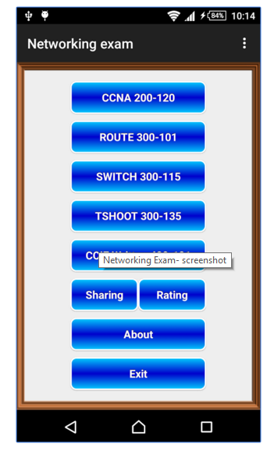

It is easy to agreed that the content of the questions covers all that is needed for Cisco CCNA and CCNP examinations, and more, including

1. Point-to-point protocols
2. IPv6
3. HSRP
4. Frame relay
5. TCP/UDP
6. VLAN
7. BGP

Figure 4‑21 - Home Page of "Network Exam" application

1. Troubleshooting

However, the fact that this application is so expansive can be a disadvantage too as the user may become disinterested and confused. With such an overwhelming range of subject matter, this application could be intimidating to a user who needs to learn the fundamentals of computer networking. The aim of the ReBoot: Networking application is to concentrate on the novice aspects of the subject of networking as a whole.

### “Cisco Packet Tracer Mobile”

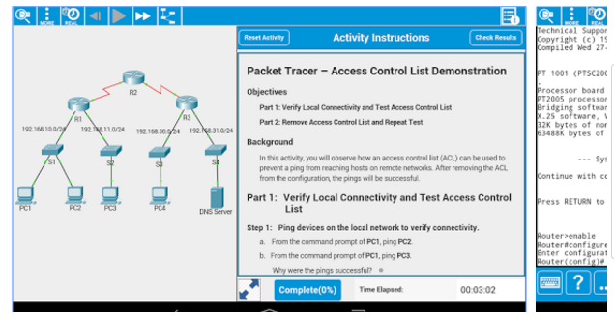

A product of Cisco™©, this application focuses on the syntax and simulated physical networking [50].

This proves to be a vital study tool, but is completely academic and provides no entertainment value.

Figure 4‑22 - An example of a question in "Cisco Packet Tracer Mobile"

### “Great Quiz (Trivia game)”

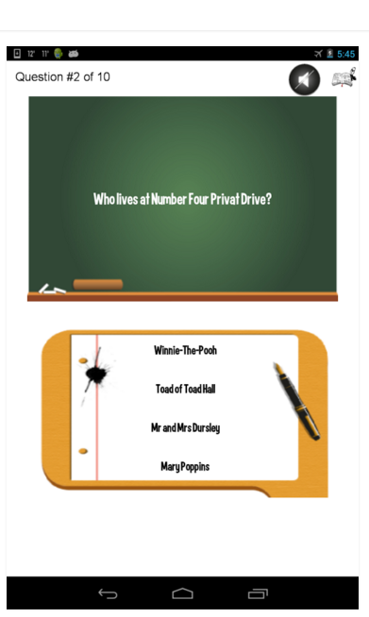

This example has a more youthful, fresh approach to a multiple choice quiz. Aesthetically, it has some fun elements and is graphically appealing to the user [51].

The content of this quiz is more to the standard which this project is being designed for. The objective is to contain this playful Look’n’feel with the usefulness of the academia.

Figure 4‑23 - An example of a question in "Great Quiz"

## Application Frameworks

This application was designed and developed taking full advantage of the elements and on-board libraries and functions of HTML5.

Written almost exclusively on JetBrains™ PhpStorm© IDE [52] and supported by Apache™ Laragon© [53] which acted as a localhost during development, this application was created to compliment the native applications of the mobile technology widely available to the market.

For compatibility with Apple™ products, the team decided to focus on iPhone5 specifications. The native OS (Operating System) of the iPhone5© is Safari.

For Android devices, the practical choice was to build a customized browser using Android™ WebView© [54]. By creating a unique browser, it was relatively easy to manipulate settings such as padding, extensions, turning JavaScript on or off, pop-ups and many other web-based functions.

To control the layout for each device, HTML5, which runs the viewport meta tag, and Bootstrap lie on top of the Android™ WebView©.

For clarity of code, this program has a polymorphic structure. This allows the program to use the *include* tag, to call and utilize independent classes to run simultaneously to form one fluid webpage.

Examples of using the *include* tag is as follows.

Figure 4‑24 - Syntax of some <include> tags

<?php include 'include/headerLOGIN.php';?>

<?php include 'levels/db\_conn.php'; ?>

## Back-End Design

The back-end design of this application has several different layers which all work together.

The primary layer lies with PhP communicating with the database using SQL queries on PHPMyAdmin [55]. This allows for the user actions to retrieve data on the server.

The effects of this type of set-up are as follows.

1. The user plays the quiz and their score changes by the PhP telling the database to store the changes on the server side
2. When the user completes a level, and with the help of embedded cookies, PhP communicates this to the database using SQL statements.
3. In the “Settings” page, when the user wants to change their username, password, email address or language, the changes are translated from PhP inputs to database using SQL. The reverse is true for when the user requests info from the database.
4. The PhP-SQL conversation also plays an important role in the password hashing which is a vital security technique in all applications which are streamed online. The author will discuss this further in the “Security” chapter (see Ch 7 for more about SQL injections and PHP hashing)

## Proposed Versioning Control System

This application was developed and managed using a Git distributed version control. This was administered through Atlassian BitBucket™ [56] and was accessed using SourceTree™ [57].

The ReBoot: Networking repository can be viewed at

<https://bitbucket.org/ryanjmackenzie/thirdyearproject>

All members had administration rights to this repository for the duration of the development. However, for continuity purposes, these administration rights are revoked to preserve the program.

# Walkthrough

## Screenshots of program walkthrough

|  |  |
| --- | --- |
| 1. Home Page   C:\Users\Rachel\AppData\Local\Microsoft\Windows\INetCache\Content.Word\1 home with cookie.png  Home page with Cookie consent | 1. Header A   C:\Users\Rachel\AppData\Local\Microsoft\Windows\INetCache\Content.Word\2 header.png  Header for unregistered accounts |
| 1. Header B   C:\Users\Rachel\Desktop\project walkthru\2a header logged in.png  Header for unregistered accounts | 1. Footer   C:\Users\Rachel\Desktop\project walkthru\3 footer.png  Register new account: this link brings user to the Sign Up page  T&C: this is a link to the Terms and Conditions of the application use  Privacy Policy: this is a link to the Privacy Policy for the users data protection |
| 1. Sign Up Page   C:\Users\Rachel\Desktop\project walkthru\4 sign-in with hover fill-in.png  Sign up Page with link to Login page | 1. Error Checking   C:\Users\Rachel\Desktop\project walkthru\5 error with email.png  An email needs to be in email format  C:\Users\Rachel\Desktop\project walkthru\6 error with pass.png  Password needs to be at least 6 characters |
| 1. Double entry of Password   C:\Users\Rachel\Desktop\project walkthru\7 double entry of pass wrong_start again.png  If the confirmation password does not match first password, the user is brought back to the start of form | 1. Log in with no password   C:\Users\Rachel\Desktop\project walkthru\8 log in no pass.png  If user tries to log in without password, the user is prompted to enter password |
| 1. Log in with no username   C:\Users\Rachel\Desktop\project walkthru\9 log in no username.png  If user tries to log in without password, the user is prompted to enter password | 1. Log in not registered   C:\Users\Rachel\Desktop\project walkthru\10 log in without being registered.png  If an unregistered user tries to log in, and error message is displayed |
| 1. Reset password   C:\Users\Rachel\Desktop\project walkthru\11 reset password linked with user registered email.png  This function is linked to the user registered email address if account issues arise | 1. Logged in   C:\Users\Rachel\Desktop\project walkthru\12 successful log in to main menu.png  Successful log in redirects user to the Main Menu |
| 1. Score Page   C:\Users\Rachel\Desktop\project walkthru\13 score page _ info fed in by cookies.png  The data to fill this page is read in from the cookie markers | 1. Quiz Page   C:\Users\Rachel\Desktop\project walkthru\14 Quiz page - levels locked.png  Each level is accessible only when the previous level is completed |
| 1. Settings Page   C:\Users\Rachel\Desktop\project walkthru\15 setting page.png  Settings menu for registered users only | 1. Change Password   C:\Users\Rachel\Desktop\project walkthru\16 change password.png  This layout is mimicked in all the settings with error checking imposed |
| 1. About Page   C:\Users\Rachel\Desktop\project walkthru\question.png  Sample of question in MCQ format. Activation of answer button store value in array | 1. Contact Page   C:\Users\Rachel\Desktop\project walkthru\19 contact page.png  Contact form generated through Foxy form which contains a captcha and the link to Live Chat |
| 1. Live Chat   C:\Users\Rachel\Desktop\project walkthru\18 live chat off line form.png  Form to instigate live chat forum | 1. Web-based View   C:\Users\Rachel\Desktop\project walkthru\20 web based site.png  View of site from a standard laptop platform with nav bar |

## UMLs

### Class Diagram

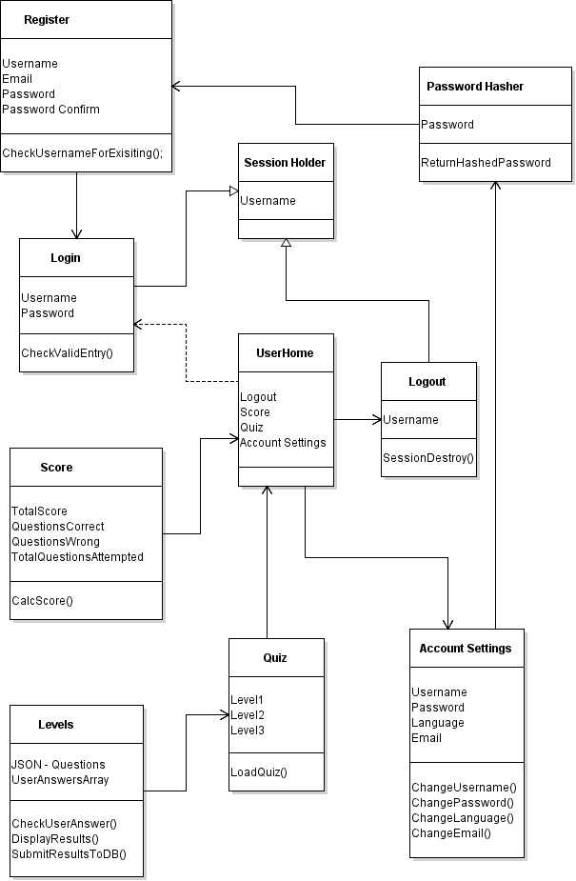

Figure 5‑1 - Class diagram of the application

### Use Case diagrams

1. Log in and Registration

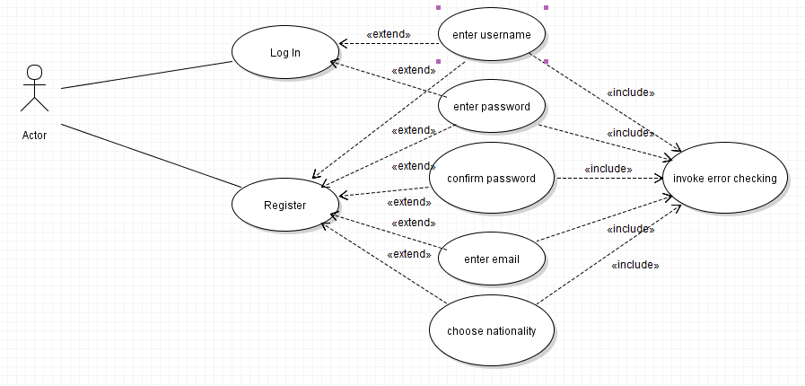

Figure 5‑2 - Log in and Registration

1. Quiz for registered and logged in users

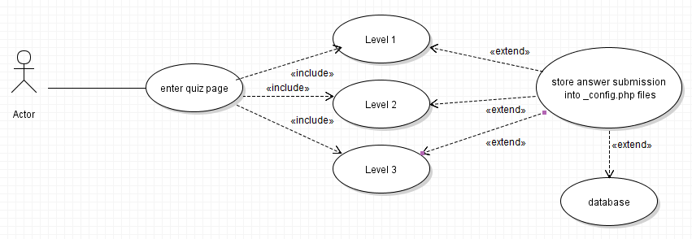

Figure 5‑3 - Quiz for logged in and registered users

1. User setting

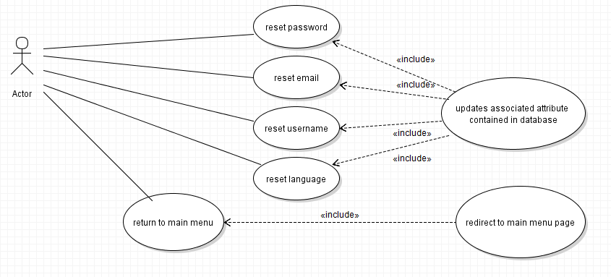

Figure 5‑4 - User settings

1. Score

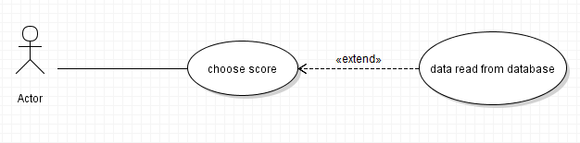

Figure 5‑5 – Score

1. Contact page

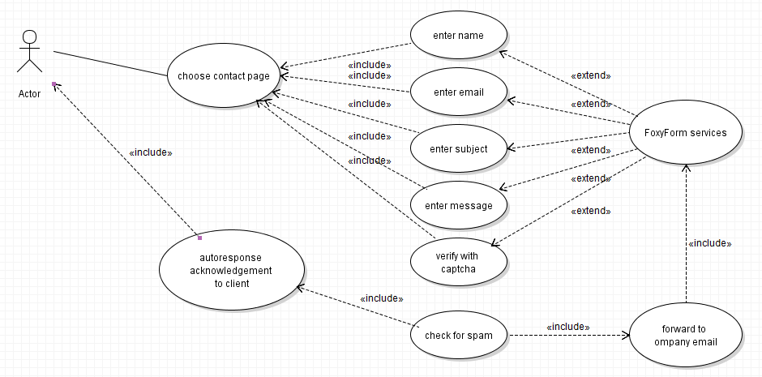

Figure 5‑6 - Contact page

1. Live Chat

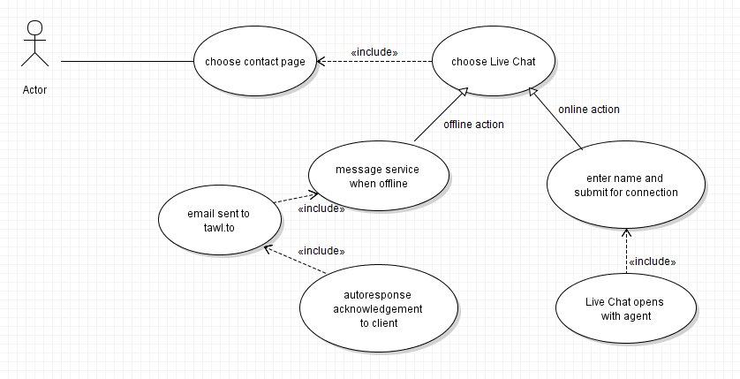

Figure 5‑7 - Live Chat

# Technology used and Additional features

This section discusses the addition technology used towards the end of the project with special attention to the launch and live features. A list of all the technology used in the duration of this build is provided for quick reference.

## Hosting Technology

This application required the use of HostGator™ CPanel© [58] to manage the Server side. This was provided by Absorb.ie. CPanel© is a user interface on the Apache™ server. Presently, it is regarded as the number one UI in use in industry.

The advantages of using a tool such as CPanel include control of administration permissions, access to a company web email service, autoresponders, reputable firewall, access to statistic to aid the monitoring of DDOS attacks (see Ch 7 for further details regarding DDOS attacks) and easy configuration of database files.

## Cookies

To add fluidity to the running of this application from the user perspective, it was agreed to use cookies in favour of PHP SESSIONS.

Cookies are small encrypted files which, when user agrees to the use of them, holds certain information regarding the user. This information may include, username, password, settings and position in the progression of the quiz. This means that the user does not need to concern themselves with re-accessing these elements manually. For the specifics of this application, the development team designed the use of cookies to hold the user position and to generate the scoring system for the results page.

This was achieved by the cookies holding the value of a simple counter and storing it in the browser with the associated user.



The functionality of the application can be compromised if the user does not accept the cookies.

Figure 6‑1 - Cookie Consent on launch of application

## Live Chat

For a more interactive feel for this application, the team considered the use of live technical support. In the current environment, a live help function helps to identify the launchability of this application as a product.

To achieve this, it was noted that there was need of a fully intact source to help house the function. This source was provided by Tawk.to [59], an online open source, fully contained, free application for visitor chatting and monitoring.

The account was registered to the company Boombastics™ using the company email address on the Absorb subdomain at info@boombastics.absorb.ie. This allowed all members of the development team to have administrative access to the messaging service and the email notifications through each of the four student email accounts. It was felt that this is important for inclusivity of all members to be able to act as technical support agents.

The vast functions of this application compliments the more entertaining factors proposed by ReBoot: Networks. Those functions include, but not restricted to, the following.

1. 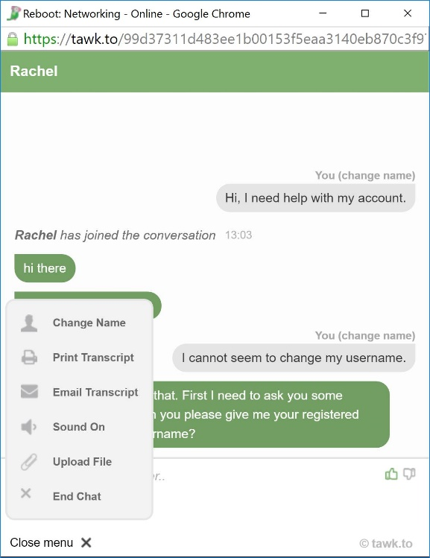Agents can communicate privately

Figure 6‑2 - Live Chat example with menu

1. There can be more than one agent for each client if the situation requires it.
2. Agents can create individual settings such as requiring a client name before connection, or requiring a general topic of conversation to ensure the best agent available can deal with the client correctly.
3. The transcript of the conversation can be printed
4. The transcript of the conversation can be emailed to the agents or designated email account.
5. Sound controls for agent comfort
6. Files and images can be uploaded from agent. This can prove useful if the agent needs to upload T&Cs or Privacy Policy for the purpose of client reference.
7. The live connection can be closed by either client or agent with notification.

## Email

The company email was registered as info@boombastics.absorb.ie. This account is set up to deliver a copy of every received email to each of the four members’ ITB student email account. These email accounts are due to expire by November 2017, at which time all members of the development team will have graduated the course.

Below is some sample emails being sent between two of the team for function testing.

A test email was sent from Ryan’s personal account to info@boombastics.absorb.ie. Rachel received the email in her student email account via info@boombastics.absorb.ie.

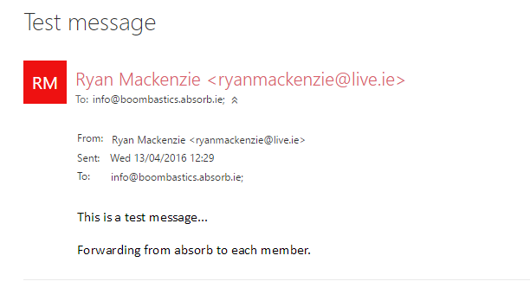

Figure 6‑3 - Test email to company email from private email, and received by agent

A test email was sent via the Contact Page. This automatically forwards the email to info@boombastics.absorb.ie, which in turn forwards a copy of the email to each of the agents. Concurrently, the client is provided with a message through the application GUI confirming the message details and a comment to say that an agent will be in touch.

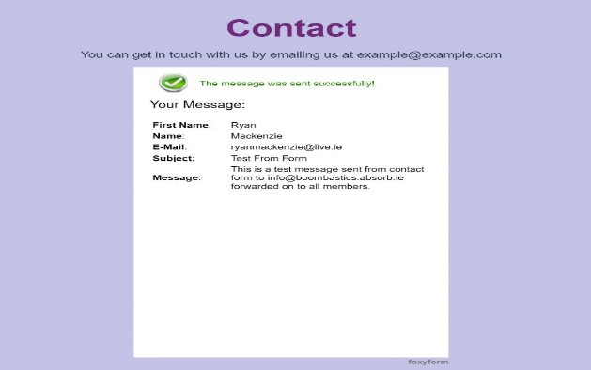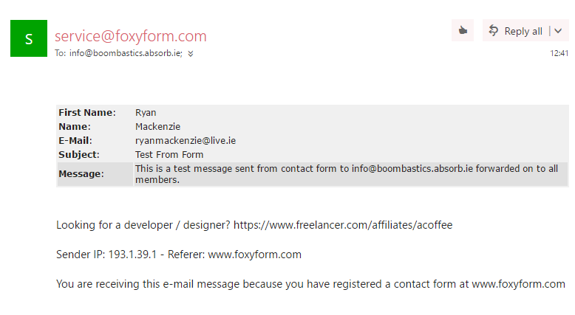

Figure 6‑4 - Autoreply to confirm message delivery to agent

Figure 6‑4 - Email from Contact Page to each agent

## Technology Quick Reference

* PhP
* PHPMyAdmin MySQL
* PHPStorm or similar
* Laragon or similar
* Java
* JavaScript
* HTML5
* CSS
* Bootstrap
* Android WebView
* Android SDK
* HostGator or similar
* GitHub/BitBucket
* Tawk.to
* Animate.css
* Wireframe.cc
* Violet UML Editor
* JSON
* Froyo 2.2
* SourceTree

# Security

This section will offer a brief insight into the areas of security and application vulnerabilities which the team discussed and investigated. These issues where always considered during every step of development, with the aim to create a more reliable and secure application both for the user and the developer.

The purpose of good security strategies when developing software is two-fold. It is important for the application to be safe from unauthorised alterations from the developer’s side. If the application was accessed and altered by an unauthorised person or persons, the functionality and integrity of the application would be compromised. On the client side, the client needs to be assured that there is stringent data protection and authenticity.

## OWASP

“The Open Web Application Security Project (OWASP) is a worldwide not-for-profit charitable organization focused on improving the security of software. Our mission is to make software security [visible,](https://www.owasp.org/index.php/Category:OWASP_Video) so that [individuals and organizations](https://www.owasp.org/index.php/Industry:Citations) worldwide can make informed decisions about true software security risks.” [60]

There is an innumerable amount of risks present when developing application. With each passing year, and with ever increasing technologies, this risk is always threatening to break the boundaries of the existing security measures. However, due to the efforts of OWASP and other organisations, this risks can be reduced considerably.

As a result of constant research, security detection and the intelligence of the best software developers, OWASP has been able to reduce the expanses of focus into ten major areas. The “OWASP Top 10” is regarded as first protocol when developing a protection strategy for web and application security.

## OWASP Top 10

### Injection (SQL Injection)

SQL Injection attacks can occur when a database and other systems are vulnerable to the external ‘injection’ of malicious or untrusted data. This data can filter down through the rest of the system to the client. This data more than likely contains viruses, malware or Trojan horses, to name a few. The severity of injection can be influenced by the programming language, the database system and/or security system.

Some of the injection flaws that can occur include LDAP Queries, SQL Queries, XPath Queries, OS Commands and Program Arguments.

The effects of Injections include the compromise of client data, which can have immeasurable consequences for both the company and the client. It is, therefore, essential for companies to employ qualified, experienced technical security.

### Broken Authentication and Session Management

These are anonymous attacks which are generated to retrieve user IDs, passwords and billing address, to name a few. The most susceptible to these attacks include online forums, or participating in social media.

How it works is actually very simple. The imposter gathers information about the target from other users on the same platform. Once enough information has been sourced, the imposter can simple request the vital information and hijack the system.

To avoid this, users are advised to log out of accounts in order to close the session. From a developer’s perspective, session expiration and login expiration can narrow the window of opportunity for these forms of attacks.

### Cross Site Scripting (XSS)

This type of vulnerability takes advantage of the security vulnerabilities of the browser rather than the site itself. Similar to SQL injections, it is difficult to trace XSS problems to its source. This method of attack involves the imposter interrupting a transfer process from the client to the web service provider. During this interruption, confidential information can be harvested without either the client or the provider being aware that the attack has occurred.

XSS vulnerabilities can be caused by malicious data or content, known as ‘spoofs’ being scripted onto the victims’ browser where the user can be unsuspectedly relieved of their password so that the user can purchase the removal of a virus. Data protection is severely compromised as a result of these attacks.

### Insecure Direct Object Reference

This can happen when a system has been insufficiently protected from attacks. It is most commonly effective when authentication levels are not checked correctly. This allows the general user to access areas of sensitive data. The most vulnerable area where this occurs is normally at the point of login.

Detectors such as “Defencely” [61] can help to track down and notify the developer of such threats or vulnerabilities. Code analysis and evaluation can help highlight any potential authentication holes in a project.

### Security Misconfiguration

This involves seeking out accounts which have default credentials, or unused pages, to gain access to a system. Good security requires having a secure configuration defined and deployed for the application, web server, database server, frameworks, and server. Secure settings should be defined, implemented, and maintained, rather than the insecure default versions. Additionally, software should be kept up to date, updating when due through secure paths.

### Sensitive Data Exposure

This attack is well thought out before the attacker engages any action. The attacker is patient to analyse the target website. This invasion deems all of the targets T&Cs and privacy is compromised. Businesses such as online eCommerce sites are targeted. Because it is database reliant, it the attacker can infiltrate this database, then the attacker has access to all the data held there.

As secure as SSL certificates are, these too can lay at risk of this attack. To prevent a breach, businesses need to have several layers of encryption built in to their systems to combat these arithmetical perpetration. It is also unadvisable to enforce automatic encryption/decryption in the database system.

### Missing Function Level Access Control

Most applications confirm the validity of access to function levels before displaying to the GUI. This needs to be true on the server side whenever a function level is accessed. Therefore only those users who have privileges to access these levels are granted entry.

It this system is not enforced correctly, attackers will gain access to confidential areas of the system. A way to restrict the risk of this occurring is to have privileged user change access credentials on a regular basis. It is also advisable to have a double-entry system for access to extremely sensitive data areas, and to restrict the number of users with authorization.

### Unvalidated Redirect and Forwards

Experienced attackers can manipulate a target into believing that they are secure. They do this by creating mimic websites which appear to be the authentic website that the target is seeking. The attacker intercepts the path to the destination and redirects the target to their site where the target enters personal credentials. This leave the target vulnerable to instant, or delayed, attacks.

### Cross Site Request Forgery (CSRF or XSRF)

This is considered the most prevalent attack from online attackers in the current market. Like many of the other techniques, this attack utilizes a forged website. For this strategy, the target is informed by the attacker that their account is suspended. To confirm this, most targets re-enter their credential, but this time into the forged site. This allows the attacker access to the targets information, thus exposing them to identity theft, theft of finances, or access to subsidiary accounts which will benefit the attacker.

Users are advised to close the session and relaunch a new session to try and avoid this. It is also good practice to clear browser cache regularly to avoid a chain of access by an attacker.

### Using Components with Known Vulnerabilities

There are certain components of a website that are naturally vulnerable, such as libraries, framework or other software modules. An attacker, if apt enough, is aware of these and can exploit them easily. The safest way to avoid this attack is to be prepared as component related weaknesses are hard to identify.

There are several actions that can be performed to reduce vulnerability.

* Upgrade any plugin-based libraries
* Employ reputable security analysts to scan and monitor the system regularly
* Enforce security protocols on the most vulnerable areas of the website
* Report all discrepancies

If a component is exploited, the danger of more attacks is dramatically increase. Applications with compromised components have a very unstable defence, and are susceptible to more grievous system attacks.

Two other very common security issues which are valid for this application are explained below.

### DDoS Attack

This is when a hacker targets the server and makes it unavailable to the users. When the server is taken offline, the hacker will either corrupt the whole website, or a certain function of a website, for their own advantage, or for their own enjoyment. An example of this would is to send a lot of URL requests to the target website. This action will create a bottleneck by forcing the server’s CPU to use all of its resources to deal with the incoming URL requests. As a result, the site will lag considerably as the CPU capacity is busy dealing with the requests, leaving little room for any other processes.

Unfortunately it is very difficult to stop or defend against this type of attack as there is not much that can be done to stop this type of attack from happening. The best this to do is to monitor and detect this type of attack. Monitoring and detection can be achieved by using the Cisco™ NetFlow Analyzer tool, or similar [62]. For this project, it was noted that Absorb™ uses CloudFlare.

### Man-in-the-middle-attack

This can occur when the client sends out a hello packet to attempt to find the destination. However, there may be a hacker posing as a destination on the route from source to destination. Hence the term “Man-in-the-middle”. This imposter sends a fake ‘hello’ message back to the source. The client is now unaware that they have made a connection with a fraudulent destination. While this connection is open, the imposter is able to gather the client input data such as bank details or passwords.

The best way to avoid such attacks is to have password encryption, and only enter sensitive information on sites where you have the Hypertext Transfer Protocol Secure (https ://) in the URL.

# Testing

This document is a report of the software testing and associated activities in each phase of the process. Just as software development is staged in phases, software testing is executed using the planning, analysis, implementation, and evaluation lifecycle.

Each phase must follow a strict set of guidelines that must be managed in order to acquire the expected results at the end of the process.

Due to the complexity of systems in current industry, there is a need for a more efficient and intelligent testing process. Any software issues or discrepancies generate significant cost in time, finance and productivity.

This document will discuss the measures taken in the testing regime of this application. Also provided is a journal of the tests carried out on this application.

## The importance of testing

Since computer communication first began commercial in the 1960s, it has grown at an extraordinary rate. As a result, security and testing has had to be developed to match this growth. In today’s environment, with access to high speed internet connections, and the need for instant and flawless communication, web applications have become the most important product for development.

As a result of its popularity, applications are more susceptible to issues and failures. Therefore, there is a need for more stringent testing protocols to ensure that the functionalities of the application is meeting the client expectations.

Every advancement in the development of software needs to be reinforced by an adequate testing formula. Without the testing, the software is regarded as flawed. Software testing plays a fundamental role and contributes to the improvement of the quality, security, and reliability of web-based and mobile applications, while reducing overheads such as time, manpower and finances.

Testing also increases failure detection and incompatibilities of a product before launch. This further reduces cost and time, while preserving the reputation of a good developer as a result of implementing a good testing schedule.

## Software Testing Phases

To manage the complexity of an adequate testing schedule, the programmer must divide the task into more defined segments. This is achieved by separating the test into multiple phases. Using this approach, test can focus on specific features and aspects of the intended software and highlight errors or inconsistencies in small manageable fragments.

Software testing can be categorized into five main test types which are applicable to this project.

1. Usability
2. Functional
3. Compatibility
4. Database
5. Installation

The following subsections will discuss each of these test types which will be used in the development of the ReBoot: Networking application.

### Usability

Usability tests are responsible for testing the complexity of user functionality. It is designed to highlight any transitional of functional glitches which the user may encounter in the basic use of the application. The following is a list of tests which will be used for the purpose of development of this product.

* Access to every page of the application
* Evaluate ease of navigation between pages
* Evaluate the number of steps required to accomplish primary tasks
* Check for spelling
* Check for confirmation message display for any update operation
* Check for broken links
* Check for image display
* Check text alignment
* Check button format is consistent and reactive
* Check for link access to Home Page from every other location in the application

### Functional

Functional tests target the functions which the application performs and it simulates this function. The purpose of this is to investigate if the functions of the application run as they were intended. These specific tests, once developed, must be performed in every test phase. This confirms that the external behaviour of the application is running at its optimum.

This phase of testing is more commonly regarded as Black Box Testing. This projects functional testing was completely automated and performed using Selenium IDE for Firefox. Some of the tests intended for this product should include the following.

* Check if asterisks are displayed in password fields
* Check mandatory fields are validated
* User password should meet the criteria of the program (i.e. not less than 6 characters)
* Check every element of each page is being displayed in correct position, in the correct format
* Test maximum length of each field to ensure the data is not truncated

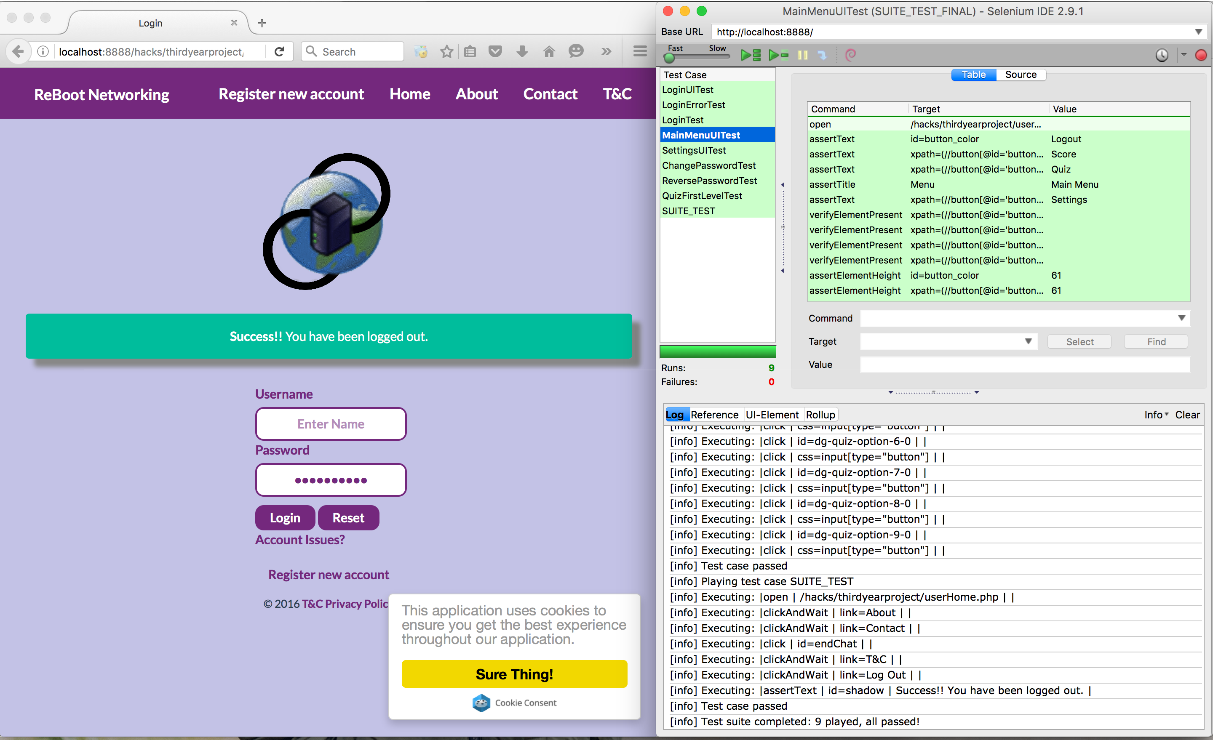

Figure 8‑1 - Functional testing performed on the application

### Compatibility

Compatibility tests are executed to ensure program compatibility of the application with different platforms and different devices. The tests to be enforced on this application will be Safari, Google Chrome, Mozilla Firefox and Safari for iOS.

The specifics of the tests will include, but will not be restricted to, the following.

* Check that images display in each of the different platforms
* Check HTML version used in development is compatible with the appropriate browser versions
* Test that JavaScript code used is functional on each of the different platforms

### Database

Database tests are performed to ensure that data updates on the application are responding as they should. It is also a way to document the structure of the database. It is expected to perform the tests using the PHPMyAdmin interface or similar interface.

The main tests to be conducted will include the following.

* Check the primary and foreign key of the table(s).
* Verify encrypted data in the database
* Verify if the column allows *NULL* or not
* Ensure that when the output is zero, then zero records are affected
* Check that data gets stored accordingly and accurately after each page submission
* Verify that data is displayed on front-end matches data stored in the back-end of the program

### Installation

Installation tests are responsible for testing if the application can be correctly installed across the server and different devices. There are several ways to conduct this testing schedule. This section will provide an outline of some of these methods.

1. Validate the prerequisite elements for the application installation. For this project the requirements are as follows.

* Clone the BitBucket repository that contains the project
* Ensure the PhP version is minimum of 5.5
* Confirm that the database is developed using MySQL
* Import and execute the database contents with the .*sql* files in the \_*installation* folder.

1. Execute the installation on multiple environments
2. Execute and update over the previous installation

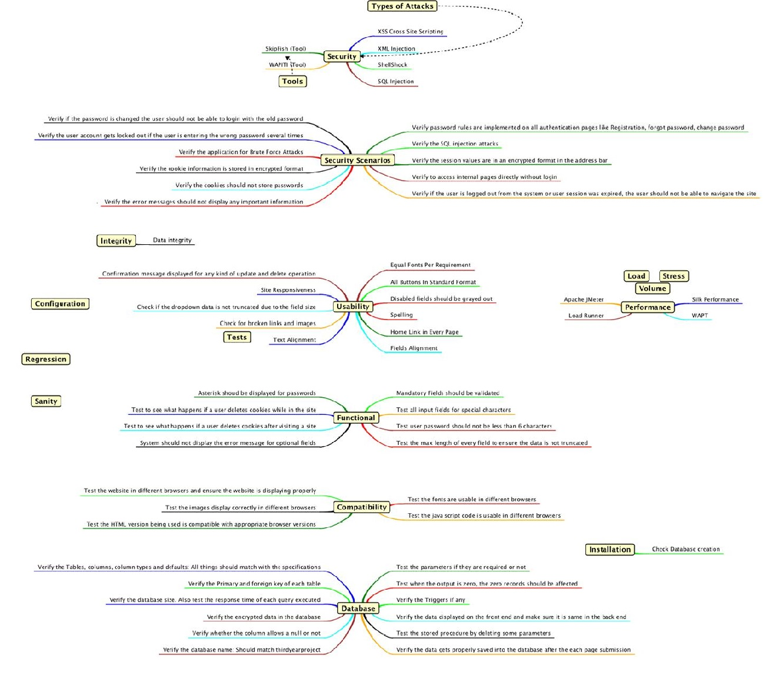

Figure 8‑2 - Mind map for Testing Regime

## Test Journal as of 24-04-2016

### Usability Tests

|  |  |
| --- | --- |
| Title #1 | Site Responsiveness |
| Purpose | Check if website fits on various screens sizes |
| Expected Result | The website and all of its elements should have a good appearance on the screen |
| Result | Safari - Pass Chrome - Pass Firefox - Pass Safari iOS - Pass |
| Recommendation | No recommendations |

|  |  |
| --- | --- |
| Title #2 | Text Alignment |
| Purpose | Check the text alignment of the website |
| Expected Result | The text must be aligned in all pages of the website |
| Result | Home page - Pass Score - Pass Quiz Level 1 - Pass Quiz Level 2 - Pass Quiz Level 3 - Pass  Settings - Pass Change Password - Pass Change Email - Pass Change Username - Pass Change Languages - Pass |
| Recommendation | Settings/Languages pages could have the language dropdown menu centralized |

|  |  |
| --- | --- |
| Title #3 | All Buttons In Standard Format |
| Purpose | Test the uniformity of the website buttons |
| Expected Result | All buttons should have the same format, color and style |
| Result | Main menu - Pass Settings - Pass Change Password - Pass Change Email - Pass Change Username - Pass Change Languages - Pass  Quiz Level 1 - Pass Quiz Level 2 - Pass Quiz Level 3 - Pass  Contact - Fail |
| Recommendation | Quiz Buttons could have been stylized with bootstrap |

|  |  |
| --- | --- |
| Title #4 | Home Link in Every Page |
| Purpose | Check if home link is present in every page of the site |
| Expected Result | A link to the home page should be present in every page |
| Result | Main menu - Pass Settings - Pass Change Password - Pass Change Email - Pass Change Username - Pass Change Languages - Pass |
| Recommendation | No Recommendations |

|  |  |
| --- | --- |
| Title #5 | Broken links and images |
| Purpose | Check for broken links and images |
| Expected Result | Should not have any broken links or images |
| Result | Main menu - Pass Settings - Pass Change Password - Pass Change Email - Pass Change Username - Pass Change Languages - Pass  Quiz Level 1 - Pass Quiz Level 2 - Pass Quiz Level 3 - Pass  About - Pass Contact - Pass Terms and Conditions - Pass |
| Recommendation | No Recommendations |

|  |  |
| --- | --- |
| Title #6 | Disabled fields should be grayed out |
| Purpose | Check if disabled fields are grayed out |
| Expected Result | Disabled buttons must be grayed out |
| Result | Quiz Level 1 - Pass Quiz Level 2 - Pass Quiz Level 3 - Pass |
| Recommendation | No Recommendations |

|  |  |
| --- | --- |
| Title #7 | Dropdown data is not truncated due to the field size |
| Purpose | Check if the dropdown data is not truncated due to the field size |
| Expected Result | The data should not be truncated or cropped |
| Result | Change Language - Pass Contact - Pass |
| Recommendation | Contact form could match website colors |

|  |  |
| --- | --- |
| Title #8 | Confirmation message displayed for any kind of update and delete operation |
| Purpose | Display confirmation message after database operation |
| Expected Result | Message displayed in green after operation succeeded or displayed in red if failed |
| Result | Change Password - Pass Change Username - Fail Change Email - Fail Change Language - Fail |
| Recommendation | Look at the database query, the problem appears to be in the query. |

### Functional Tests

|  |  |
| --- | --- |
| Title #1 | Asterisks for passwords |
| Purpose | Displayed asterisks in passwords fields |
| Expected Result | Asterisk should be displayed for passwords |
| Result | Login Page - Pass Change Password - Pass |
| Recommendation | No recommendations |

|  |  |
| --- | --- |
| Title #2 | User Password length |
| Purpose | Force user to create a more secure password |
| Expected Result | Password must be at least 6 characters |
| Result | Register new account - Pass Change Password - Fail |
| Recommendation | Fix the internal page to validate the fields with javascript |

|  |  |
| --- | --- |
| Title #3 | Validate mandatory fields |
| Purpose | Ensure that mandatory fields data are in the correct format |
| Expected Result | Must exhibit a message if field is invalid |
| Result | Change Password - Fail Sign up:  Username - Pass  E-mail - Pass  Password - Pass  Password Repeat - Pass |
| Recommendation | No recommendations. |

### Compatibility Tests

|  |  |
| --- | --- |
| Title #1 | Test the website in different browsers and ensure the website is displaying properly |
| Purpose | Check if there any differences between browsers exhibitions |
| Expected Result | Website should display properly |
| Result | Chrome - Pass Safari - Pass Firefox - Pass |
| Recommendation | No recommendations |

|  |  |
| --- | --- |
| Title #2 | Fonts |
| Purpose | Test the fonts are usable in different browsers |
| Expected Result | Fonts should display properly |
| Result | Chrome - Pass Safari - Pass Firefox - Pass |
| Recommendation | No recommendations |

|  |  |
| --- | --- |
| Title #3 | Images |
| Purpose | Test the images display correctly in different browsers |
| Expected Result | Images should display properly |
| Result | Chrome - Pass Safari - Pass Firefox - Pass |
| Recommendation | No recommendations |

|  |  |
| --- | --- |
| Title #4 | Javascript |
| Purpose | Test the java script code is usable in different browsers |
| Expected Result | The Javascript must return the same output in different browsers |
| Result | Chrome - Pass Safari - Pass Firefox - Pass |
| Recommendation | No recommendations. |

|  |  |
| --- | --- |
| Title #5 | HTML |
| Purpose | Test the HTML version being used is compatible with appropriate browser versions |
| Expected Result | The HTML should be compatible with browsers most recent versions |
| Result | Chrome 49.0.2623.110 - Pass Safari 9.1 (11601.5.17.1) - Pass Firefox 45.0.2 - Pass |
| Recommendation | No recommendations |

### Database Tests

|  |  |
| --- | --- |
| Title #1 | Primary and foreign keys |
| Purpose | Verify the Primary and foreign key of each table |
| Expected Result |  |
| Result | Table questions - questionid is the Primary key - Pass Table users - user\_id is the Primary key - Pass |
| Recommendation | No recommendations. |

|  |  |
| --- | --- |
| Title #2 | Database size |
| Purpose | Verify the database size |
| Expected Result | Database should not exceed 10MB |
| Result | Table questions - 16kb Table users - 48kb Total database size 64k - Pass |
| Recommendation | No recommendations. |

|  |  |
| --- | --- |
| Title #3 | Database Response time |
| Purpose | Test the response time of each query executed |
| Expected Result | Query should have optimal execution time |
| Result | Registering new user - 0.0033 seconds - Pass Deleting user - 0.0021 seconds - Pass Change user Password - 0.0011 seconds - Pass |
| Recommendation | No recommendations. |

|  |  |
| --- | --- |
| Title #4 | Encrypted password |
| Purpose | Verify if the user password is encrypted in the database |
| Expected Result | The user password should be encrypted in the MD5 format |
| Result | user\_password\_hash column is encrypted in MD5 format - Pass |
| Recommendation | No recommendations. |

|  |  |
| --- | --- |
| Title #5 | Database Name |
| Purpose | Verify the database name |
| Expected Result | Should match "majorgroupproject" |
| Result | System database name is “majorgroupproject" - Pass |
| Recommendation | No recommendations. |

|  |  |
| --- | --- |
| Title #6 | Output zero |
| Purpose | Test when the output is zero |
| Expected Result | Zero records should be affected |
| Result | Executed query for a non-existent user - Returned zero with zero records affected - Pass |
| Recommendation | No recommendations. |

|  |  |
| --- | --- |
| Title #7 | Data insertion verification |
| Purpose | Verify the data gets properly saved into the database after the each page submission |
| Expected Result | The data should be saved after each page submission |
| Result | Login - Pass Sign up - Pass Change Password - Pass Change email - Pass Change username - Pass Change Languages - Pass Quiz - Pass |
| Recommendation | No recommendations. |

### Installation Tests

|  |  |
| --- | --- |
| Title #1 | Database creation |
| Purpose | Test the database import |
| Expected Result | Should create entire database with some users and questions |
| Result | Users - Pass Questions - Pass |
| Recommendation | No recommendations |

## Notes

\*For the user subscription test, PHPUnit was used for this project, along with Selenium web driver.

\*\*In the class we declared a function setUp() with the data to connect the web drive with the browser.

\*\*\*In the testFormSubmissionWithUsername() function we used the assert functions provided by Selenium to test if the user could login into the system

# Findings

## Score Function

Cookies, rather than PhP sessions, were used to hold the users current position. However, this function was incomplete and requires further investigation and implementation.

When the full pool of 300 questions per level was to be loaded, the plan was to devise a function which would run a block of 10 questions and then produce a progressive result. This would ensure that the user complete each block of 10 questions correctly before advancing on to the next block of 10 questions.

The intention was to record the position of the user via cookies with blocks of 10 questions, for the duration of the level pool of 300 questions.

## Level 3

When this application was initially devised, level 3 was to be formatted for textual input for answers. Due to time restraints and the complexity of the task, and while the team gave its best effort, level 3 was downgraded to a radio button format to mimic the layout and functionality of level 1 and level 2.

## Sounds

It was hoped that there would be background music throughout the running of application. It was expected to have some mp3 or .wav files for button activation sounds and a fanfare appropriate to the users score on the results page.

However, considering the timeframe allowed for this project, the use of sound did not come to fruition.

# Conclusion

On completion of the development of this application, it was agreed that while some aspects of the project did not meet the initial project proposal, the application, on the whole, reached significant levels of expertise.

It was noted, by the point of delivery, that the team utilised the majority of the computing skills learned to date, but that the realms of self-learned knowledge were significantly expanded.

There was immense satisfaction for the team in seeing the plan come to fruition. While it was envisioned to have an MCQ styled quiz application in the topic of computer networking, what transpired at the end was a beta product with the potential to be finessed to official launch standards.

The idea came from one of the team members’ experience of entering ITB as an advanced student and carrying zero networking concepts or experience. The finished product is a stand-alone application to assist any student to grasp the fundamentals of computer networking in a challenging, yet fun, environment.

It is reasonable to say that this development carried its fair share of debate and unrest, as does any team project. But the end, all our intrapersonal issues were resolved. In fact, things were so harmonious, that the 3-person team invited a new member to the family. This addition brought alternative approaches to the build, and by working together, we all benefited from the new skills of communication and patience which we readily acquired.

It is with hope that this application is fully developed in the future, to help quash the daunting attitude towards computer networking for potential students. This project was successful and enjoyable.

# Appendix

1. Initial investigations into the following
   1. Existing academic application in the field of computer networking
   2. Existing non-academic applications which follow the MCQ format
   3. MCQ verses non-MCQ formatting
   4. Application vulnerabilities
   5. Security solutions for applications
   6. Availability of application development software at open source level
   7. Legal implications involved in launching an application
2. Hosting sourced and a subdomain was created and set to the project specifications
3. Secured SSL certification
4. Created template containing basic layout of GUI using Bootstrap
5. Developed android application
6. T&Cs and Privacy Policy composed
7. Designed basic CSS using several developed templates as a base
8. Developed a database for users and questions
9. Testing and troubleshooting of database using template site….PASSED
10. Implemented login page by connecting database to application
11. Enforced ‘hashing’ encryption on to passwords
12. Developed the main menu and all pages associated with it
13. Converted question and answer database into JSON format
14. Implemented Quiz page to read from JSON file
15. Testing and troubleshooting of JSON file reading….PASSED
16. Company and members’ biographical composed
17. Implemented transition between levels of quiz
18. Testing and troubleshooting of level 1 and level 2….PASSED
19. Investigated plausibility of textual input for level 3
20. Refined CSS to create continuity throughout the application
21. Implemented animations
22. Implemented customer contact form
23. Developed Live Chat facilities
24. Testing and troubleshooting with peer volunteers that the Live Chat function works as expected….PASSED
25. Enforced encryption and ‘hashing’ to passwords
26. Clarified animations and responsiveness
27. Error checking was implemented
28. Initial Testing schedule was introduced
29. Extensive testing and fixing ran
30. Implemented Cookies to unlock levels and hold user position and score
31. Minor Graphics adjustments
32. Launched online by Ryan
33. Final testing of functionality, graphics, responsiveness and database responses
34. Proof-read all code and comments
35. Post-Launch troubleshooting
36. BETA version demonstrated to ITB on 27-04-16
37. Testing documentation was accrued throughout the later phases of the development process
38. Thesis was composed throughout the entire duration of the application development

# References

[1] Driftwoodsoftware.com, 'Driftwood Software', 2015. [Online]. Available: http://www.driftwoodsoftware.com/quiznet.HTML. [Accessed: 21- Oct- 2015].

[2] QuizUp, 'QuizUp', 2015. [Online]. Available: https://www.quizup.com/en. [Accessed: 21- Oct- 2015].

[3] Apps.facebook.com, “Quiz on Facebook | Facebook”, 2015. [Online]. Available: https://apps.facebook.com/fb-quizzes/?ref=aw&gclid=Cj0KEQjwqZKxBRDBkNmLt9DejNgBEiQAq8XWPl9BuKL-VuuJVTBNtN7fx9B1k0dwPn427aYd5BjdhaUaAlrX8P8HAQ. [Accessed: 19- Oct- 2015].

[4] L. Dan Cheng and X. Wang, 'Mobile application tools for learning and quiz based on Android', 2013 IEEE 63rd Annual Conference International Council for Education Media (ICEM), 2013.

[5] M. Murphy, “The busy coder's guide to advanced Android development.” United States: Commons Ware, 2011.

[6] Lion Vision, “The Prototyping Model”. 2015. [Online-Image] Available: http://www.lionvisionits.com/Development-Process.aspx. [Accessed: 21-Oct-2015].

[7] Developer.Android.com, 'Download Android Studio and SDK Tools | Android Developers', 2015. [Online]. Available: https://developer.Android.com/sdk/index.HTML. [Accessed: 21- Oct- 2015].

[8] A. Highlights, 'Android 2.2 Platform Highlights | Android Developers', Developer.Android.com, 2015. [Online]. Available: http://developer.Android.com/about/versions/Android-2.2-highlights.HTML. [Accessed: 21- Oct- 2015].

[9] J. Drake, Z. Lanier, C. Mulliner, P. Oliva, S. Ridley and G. Wicherski, “Android hacker's handbook.” Indianapolis, IN: Wiley, 2014.

[10] A. Misra, “Android security.” Boca Raton, FL: CRC Press, 2013.

[11] Absorb, 'Absorb.ie', Absorb.ie, 2015. [Online]. Available: http://absorb.ie. [Accessed: 21- Oct- 2015].

[12] J. Mathews, 'Just Whose Idea Was All This Testing?’ Washingtonpost.com, 2015. [Online]. Available: http://www.washingtonpost.com/wp-dyn/content/article/2006/11/13/AR2006111301007.HTML. [Accessed: 10- Nov- 2015].

[13] D. Ravitch, 'The Fall of the Standard-Bearers', the Chronicle of Higher Education, 2006. [Online]. Available: http://chronicle.com/article/The-Fall-of-the/6169. [Accessed: 13- Nov- 2015].

[14] C. Davidson, 'Now You See It: How Technology and Brain Science Will Transform Schools and Business for the 21s t Century'. New York: Penguin, 2011, Chapter 4.

[15] P. Race, S. Brown, J. Bull, A. Cann and E. Pawley, *Computer-assisted assessment of students*. London: Kogan Page, 1999, Chapter 4.

[16] Multiplechoicequestionsservice.com, 'Advantages of Taking Multiple Choice Questions Tests | Multiple Choice Questions', 2015. [Online]. Available: http://www.multiplechoicequestionsservice.com/multiple-choice-questions-advantages/. [Accessed: 12- Nov- 2015].

[17] M. Christensen, Ph.D., 'Essay vs. Multiple-Choice Exams: The Ups and Downs of Each Format', CLEAR Annual Conference, Phoenix, AZ, 2005.

[18] A. Miller, B. Imrie and K. Cox, Student assessment in higher education. London: Kogan Page, 1998.

[19] Chiropractic Economics, 'National Board of Chiropractic Examiners, NBCE, Mark G. Christensen, Paul M. Tullio Award', 2012. [Online]. Available: http://www.chiroeco.com/nbce-director-of-testing-receives-paul-m-tullio-award/38815/. [Accessed: 10- Nov- 2015].

[20] David Jennings; (2006) 'A Problem and an Opportunity: E-Learning a case for collaboration' In: Savin-Baden M. and Wilkie K (eds). Problem Based Learning Online. Open University Press: McGraw-Hill Education.

[21a] Kirkwood, Adrian and Price, Linda (2008). Assessment and Student Learning – a fundamental relationship and the role of information and communication technologies. Open Learning, 23(1) pp. 5–16.

[21b] Tang, K. (1992), ‘Perceptions of task demand, strategy attributions and student learning’, Research and Development in Higher Education 15, 474–480.

[22] Scouller, K.M. and Prosser, M. (1994). ‘Students’ experiences in studying for multiple choice question examinations’, Studies in Higher Education 19, 267–279

 [23] Oxforddictionaries.com, "e-learning - definition of e-learning in English from the Oxford dictionary", 2016. [Online]. Available: http://www.oxforddictionaries.com/definition/english/e-learning. [Accessed: 02- Dec- 2015].

 [24]"Michael Young - Dartington", Dartington, 2016. [Online]. Available: https://www.dartington.org/about/our-history/dartington-whos-who/michael-young/. [Accessed: 06- Dec- 2016].

[25] Kurniawan Teguh Martono and Oky Dwi Nurhayati, "IMPLEMENTATION OF ANDROID BASED MOBILE LEARNING APPLICATION AS A FLEXIBLE LEARNING MEDIA," International Journal of Computer Science Issues (IJCSI), vol. 11, pp. 168, 2014.

[26] YouTube, 'what is The Internet of Things?’ 2015. [Online]. Available: https://www.youtube.com/watch?v=LVlT4sX6uVs. [Accessed: 20- Nov- 2015].

[27]"About Jonathan Strickland", HowStuffWorks, 2011. [Online]. Available: http://science.howstuffworks.com/jonathan-strickland-author.htm. [Accessed: 06- Apr- 2016].

[28] S. Kurkovsky, "Can mobile game development foster student interest in computer science?" in Games Innovations Conference, 2009. ICE-GIC 2009. International IEEE Consumer Electronics Society's, 2009, pp. 92-100.

[29]"Socrative", Socrative.com, 2016. [Online]. Available: http://www.socrative.com/. [Accessed: 06- Apr- 2016].

[30] Paul POCATILU, "Developing Mobile Learning Applications for Android using Web Services," Informatica Economica Journal, vol. 14, pp. 106-115, 2010.

[31] PhP.net, (2015). *PHP: Hypertext Preprocessor*. [Online] Available at: http://www.PhP.net [Accessed 14 Nov. 2015].

[32] "PHP: History of PHP - Manual", Php.net, 2016. [Online]. Available: http://php.net/manual/en/history.php.php. [Accessed 14 Nov. 2015].

[33] Computerhope.com, (2015). “What is java?” [Online] Available at: http://www.computerhope.com/jargon/j/java.htm [Accessed 17 Nov. 2015].

[34] "PHP: News Archive - 2015", Php.net, 2015. [Online]. Available: http://php.net/archive/2015.php. [Accessed: 13- Nov- 2015].

[35] SearchSOA, (2015). What is HTML (Hypertext Markup Language)? - Definition from WhatIs.com. [Online] Available at: http://searchsoa.techtarget.com/definition/HTML [Accessed 16 Nov. 2015].

[36] Lie, H. and Bos, B. (1997). Cascading style sheets. Harlow, England: Addison Wesley Longman.

[37] Techterms.com, (2015). JavaScript Definition. [Online] Available at: http://techterms.com/definition/javascript [Accessed 18 Nov. 2015].

[38] E. Protalinski, "16 months in, Lollipop becomes the most used Android version",VentureBeat, 2016. [Online]. Available: http://venturebeat.com/2016/03/08/16-months-in-lollipop-becomes-the-most-used-android-version/. [Accessed: 13- Apr- 2016].

[39] Mark Otto, "CSS · Bootstrap", Getbootstrap.com, 2016. [Online]. Available: http://getbootstrap.com/css/. [Accessed: 16- Oct- 2015].

[40] P. Contributors, "phpMyAdmin", phpMyAdmin, 2016. [Online]. Available: https://www.phpmyadmin.net/. [Accessed: 13- Dec- 2015].

 [41]"Wireframe.cc - minimal wireframing tool", Wireframe.cc, 2016. [Online]. Available: https://wireframe.cc/. [Accessed: 19- Oct- 2015].

 [42] J. Gage, Color and meaning. Berkeley: University of California Press, 1999, pp. 21-38.

[43] "Meaning of Colors in Color Psychology", Empowered By Color, 2016. [Online]. Available: http://www.empower-yourself-with-color-psychology.com/meaning-of-colors.html. [Accessed: 03- Nov- 2015].

[44] E. Futterman, "Which Color Should You Use For Your Icon?” The Next Web, 2014. [Online]. Available: http://thenextweb.com/dd/2014/04/01/standing-sea-blue-color-pick-icon/. [Accessed: 19- Oct- 2015].

[45] "15 Blue Logos That Evoke Precision - Inspiredology", Inspiredology, 2010. [Online]. Available: http://inspiredology.com/15-blue-logos-that-evoke-precision/. [Accessed: 26- Jan- 2016].

[46] D. Eden, "Animate.css", Daneden.github.io, 2016. [Online]. Available: https://daneden.github.io/animate.css/. [Accessed: 16- Feb- 2016].

[47] "Using CSS animations", Mozilla Developer Network, 2016. [Online]. Available: https://developer.mozilla.org/en-US/docs/Web/CSS/CSS\_Animations/Using\_CSS\_animations. [Accessed: 16- Feb- 2016].

[48] "Quiz Maker Script", Dhtmlgoodies.com, 2016. [Online]. Available: http://www.dhtmlgoodies.com/?whichScript=quiz-maker. [Accessed: 12- Feb- 2016].

[49] Play.google.com, 2016. [Online]. Available: https://play.google.com/store/apps/details?id=com.namsunix.networkingexam&rdid=com.namsunix.networkingexam. [Accessed: 06- Oct- 2015].

[50] Play.google.com, 2016. [Online]. Available: https://play.google.com/store/apps/details?id=com.netacad.PacketTracerM. [Accessed: 06- Oct- 2015].

[51] Play.google.com, 2016. [Online]. Available: https://play.google.com/store/apps/details?id=net.equasoft.quizclass. [Accessed: 06- Oct- 2015].

[52] "PhpStorm IDE:: JetBrains PhpStorm", JetBrains, 2016. [Online]. Available: https://www.jetbrains.com/phpstorm/ [Accessed: 15- Sep- 2015].

[53] "Laragon - Turns your computer into a powerful server", Laragon.org, 2016. [Online]. Available: https://laragon.org/. [Accessed: 15- Sep- 2015].

[54] "WebView | Android Developers", Developer.android.com, 2016. [Online]. Available: http://developer.android.com/reference/android/webkit/WebView.html. [Accessed: 29- Sep- 2015].

[55] p. contributors, "phpMyAdmin", phpMyAdmin, 2016. [Online]. Available: https://www.phpmyadmin.net. [Accessed: 17- Sep- 2015].

[56] "Bitbucket - the Git solution for professional teams | Atlassian", Atlassian, 2016. [Online]. Available: https://www.atlassian.com/software/bitbucket. [Accessed: 13- Sep- 2015].

[57] "Free Mercurial and Git Client for Windows and Mac | Atlassian SourceTree", Sourcetreeapp.com, 2016. [Online]. Available: https://www.sourcetreeapp.com/. [Accessed: 13- Sep- 2015].

[58] "Website Hosting Services, VPS Hosting & Dedicated Servers - HostGator", Hostgator.com, 2016. [Online]. Available: http://www.hostgator.com/. [Accessed: 10- Oct- 2015].

[59] "The 100% FREE live chat application for your website!”, Tawk.to, 2016. [Online]. Available: https://www.tawk.to/. [Accessed: 01- Feb- 2016].

[60] "OWASP", Owasp.org, 2016. [Online]. Available: https://www.owasp.org/index.php/Main\_Page. [Accessed: 02- Oct- 2015].

[61] "Security Experts Protecting Your Site 24/7 | Defencely", Defencely.com, 2016. [Online]. Available: https://www.defencely.com/. [Accessed: 30- Sep- 2015].

[62] "Cisco IOS NetFlow", Cisco, 2016. [Online]. Available: http://www.cisco.com/c/en/us/products/ios-nx-os-software/ios-netflow/index.html. [Accessed: 30- Sep- 2015].

# Bibliography

1. A. Littlejohn, Reusing online resources. London: Kogan Page, 2003.
2. S. Mishra, 'Reusing Online Resources: A sustainable approach to e-learning', The International Review of Research in Open and Distributed Learning, vol. 5, no. 1, 2004.
3. N. Uddin and E. Gaspar, 'Game-Based Learning App Based on Google PlayN', IEEE International Conference on Teaching, Assessment and Learning for Engineering (TALE), Bali Dynasty Resort, Kuta, Indonesia, 2013.
4. E. Olayemi, 'Multiple choice questiones as a tool for assessment in medical education', African Journals Online (AJOL), vol. 12, no. 1, 2012.
5. Li Dan Cheng and Xiao Cheng Wang, "Mobile application tools for learning and quiz based on Android," in 2013, pp. 1-1.
6. K. Scouller, "The influence of assessment method on students’ learning approaches: Multiple choice question examination versus assignment essay, "Higher Education, vol. 35, pp. 453-472, 06, 1998.
7. A. Wu and A. I. Wang, "Comparison of Learning Software Architecture by Developing Social Applications versus Games on the Android Platform, "International Journal of Computer Games Technology, vol. 2012, pp. 1-10, 2012.

1. Note: Release date was December 2015 ( <http://php.net/archive/2015.php> ) [↑](#footnote-ref-1)